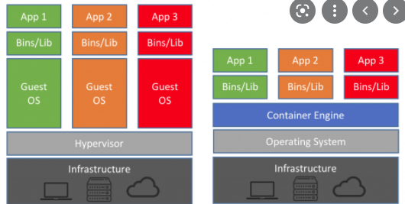

**Vitualization:**

what is virual machne --

VM --Few software needs Linux, sp viruatl images are created,we use VM ware to launch the OS

VM is software which runs an image of guest OS in existing OS.

VM is a software that is used to run guest OS such as Linux.Is an image

It is a mechanism of Running multiple Guest OS on the Host OS.

Infra str—HDD, monitor, ram,mouse , kb –all guest OS will run on host OS, it will use all the resources of HOST OS.

Advantages::

Same resources are used by HOST and guset OS ex kb,mouse . so cost will reduce .

Host OS 16 GB RAM:

Actual RAM Allocation Actual RAM Usage Free RAM

OS1: 6GB 3 GB 3 GB

OS2: 4GB 2 GB 2 GB

OS3: 6GB 4 GB 2 GB

16 GB 9 GB 7 GB

We are allocating Host RAM to all guest OS.

Free RAM cannot be used for other OS . 7 GB

**Limitations:**

unused RAM can not be used is the limitation in virtualization. We have to configure Ram at the time of guest OS creation .

Minimum boot up time of Guest OS will be min 1 min but in real time application we need the OS should boot in fraction of seconds .so long bootup time is one of the limitation.

**All Guest OS are managed by hypervisor.**

Running application on remote OS is slower than running App on Host OS.

Hyper images are not scalable.

App3

App2

App1

Bins/Lib

Bins/Libs

Bins/Libs

Hypervisor

Host OS(Windows)

Infrastructure (CPU , MONITOR, HDD)

Guest OS

Guest OS(MAC)

Guest OS(Linux)

Viry

Host os=> Hypervisor=>(Guest os1,Guest os2....)=>(Bin& Lib, Bin & Lib 2.....)=>(App1,App2,.....)

1.Virtualization is a technique of importing a guest os on the top of host os.

2.This technique is revolution in the beginning because Developers run the different application in different vms all running on same host.

3.This eliminate the need of extra h/w resource and enable the backup allowing the the recovery in failure conditions

4.lowering the total cost of foundation.

Advantages

==========

1.Multiple OS in the same machine

2.Easy Maintainance and Recovery

3.Lower total cost of Ownership

Disadvantages

=============

1.Multiple VMs Lead to unstable performance

2.Hypervisors are not as efficient as a host os

3.Long Boot up process (Approximate 1 minute)

4.This is using the host system resources

5.This is very critical in case of real time applications where fast processing is required.

6.scaling the no of vms is tedious and costly affair

**Containerization:**

**In Host OS on which container engine is installed consider as docker engine .**

**Different container engines platform**

**===================**

**Docker**

**Container D**

**RKT**

For launching container we need an image.

**Image : OS + Application+ Libraries.**

From image we can create n no of container. for new changes we have to create a new container. or we can modify the image.

Let ustake an example we have create an image with java class. we can create no of container with the same image. But if we want to add new functionality in a class then we have to create a new image and then a container.

| **Sr. No.** | **Key** | **Virtualization** | **Containerization** |
| --- | --- | --- | --- |
| 1 | Basic | Virtualization is the technology which can simulate your physical hardware (such as CPU cores, memory, disk)  and represent it as seperate machine | Containerization is os-level virtualization. It doesn't simulate the entire physical machine |
| 2 | Detaching Layer | It used  Hypervisor to detach the physical machine | It used docker engine in case Docker |
| 3 | Isolation Level | It has hardware level isolation so fit is fully secured | It has process level isolation |
| 4. | LightWeight | It is heavyweight | It is very lightweight |
| 5. | Portable | It is not portable | It is very portable. We can build, ship and run anywhere |

**Docker Architecture:**

Download toolbox or docker desktop for windows.

<https://docker-docs.netlify.app/toolbox/toolbox_install_windows/#what-you-get-and-how-it-works>

checks :

What you get and how it works

Docker Toolbox includes the following Docker tools:

* Docker CLI client for running Docker Engine to create images and containers
* Docker Machine so you can run Docker Engine commands from Windows terminals
* Docker Compose for running the docker-compose command
* Kitematic, the Docker GUI
* the Docker QuickStart shell preconfigured for a Docker command-line environment
* Oracle VM VirtualBox

We can use online sandbox for docker

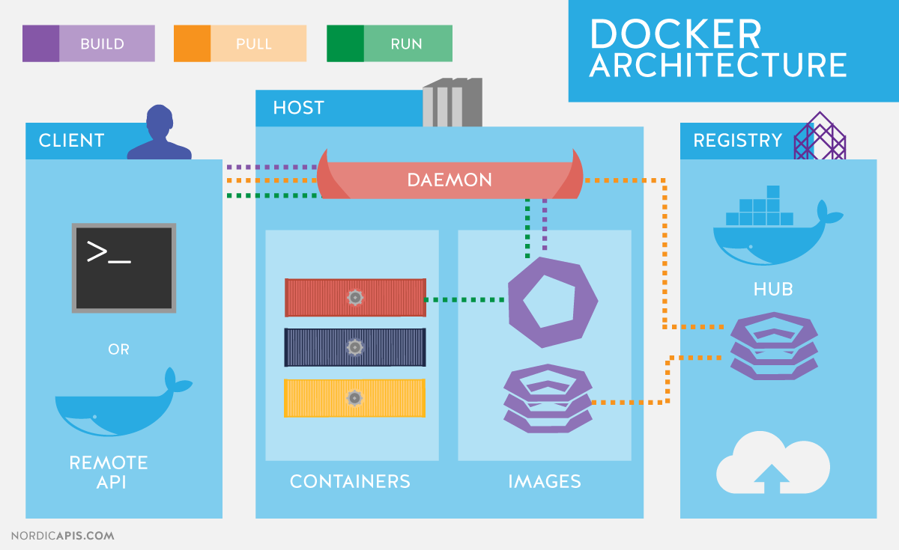

Docker CLI

When we run for first time no containers and images .

Docker hub is the site where we can get basic docker images.

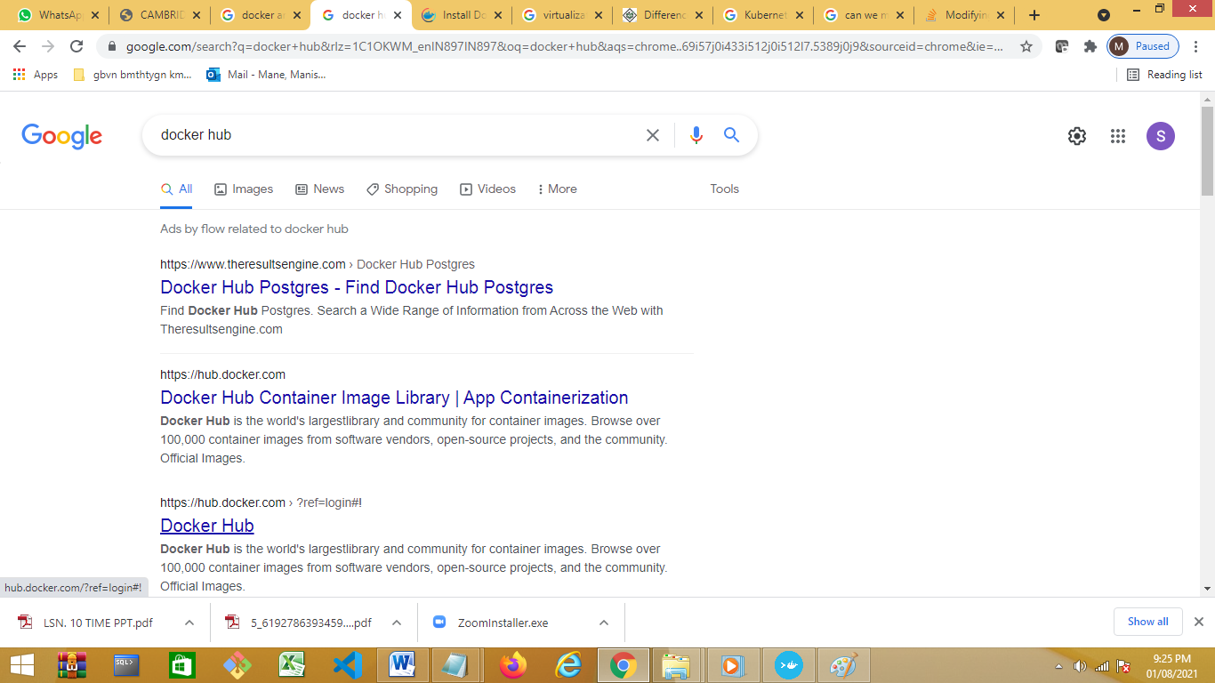

Docker Hub login manishaatos pwd Kiran@2008

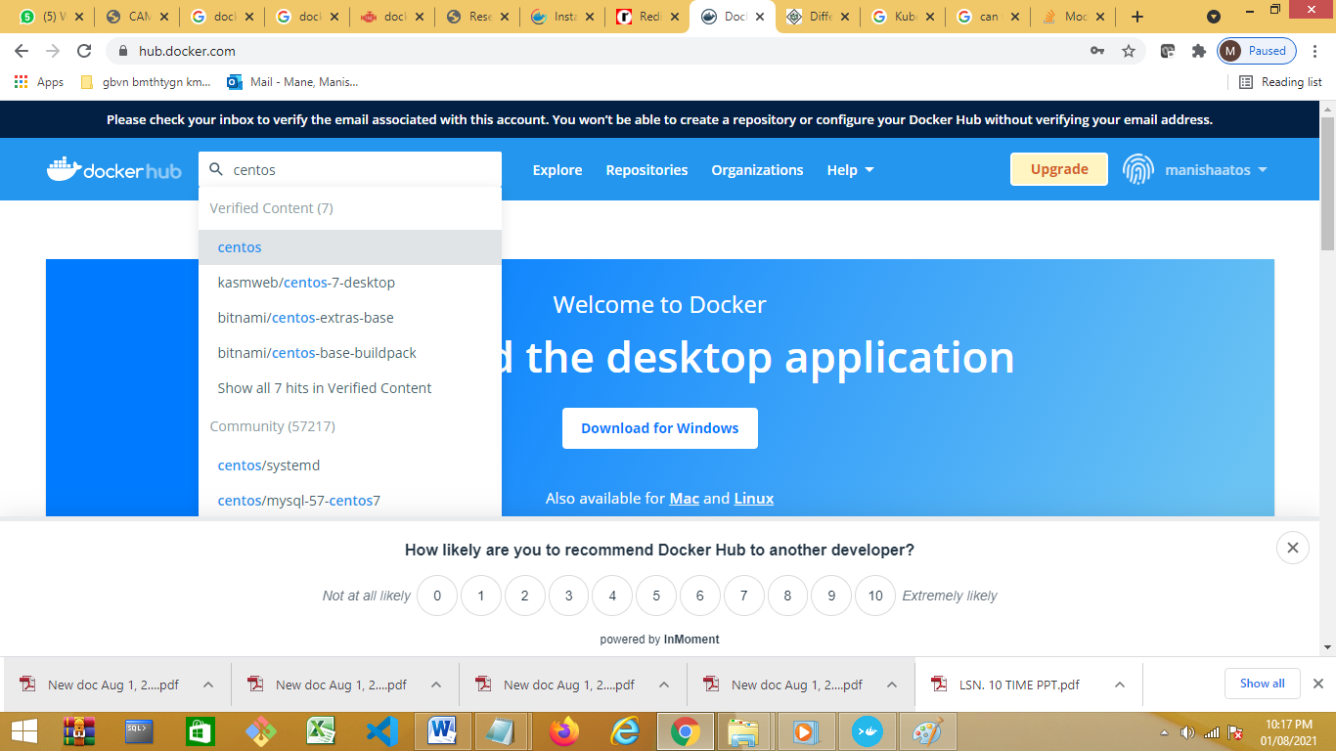

Docker pull centoos with the help of cli we are pulling remote image to host machine.From image on local machine we can create n no of containers .

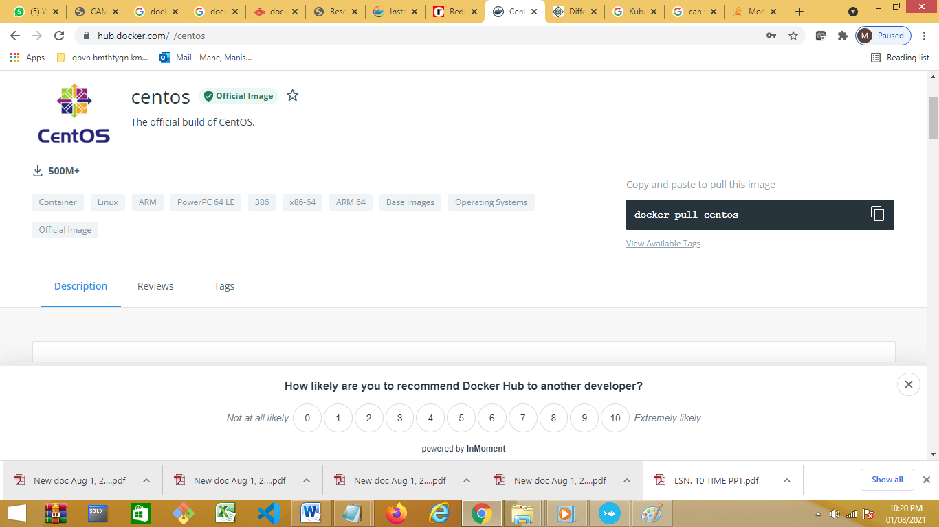

Instead of local we can use docker sandbox

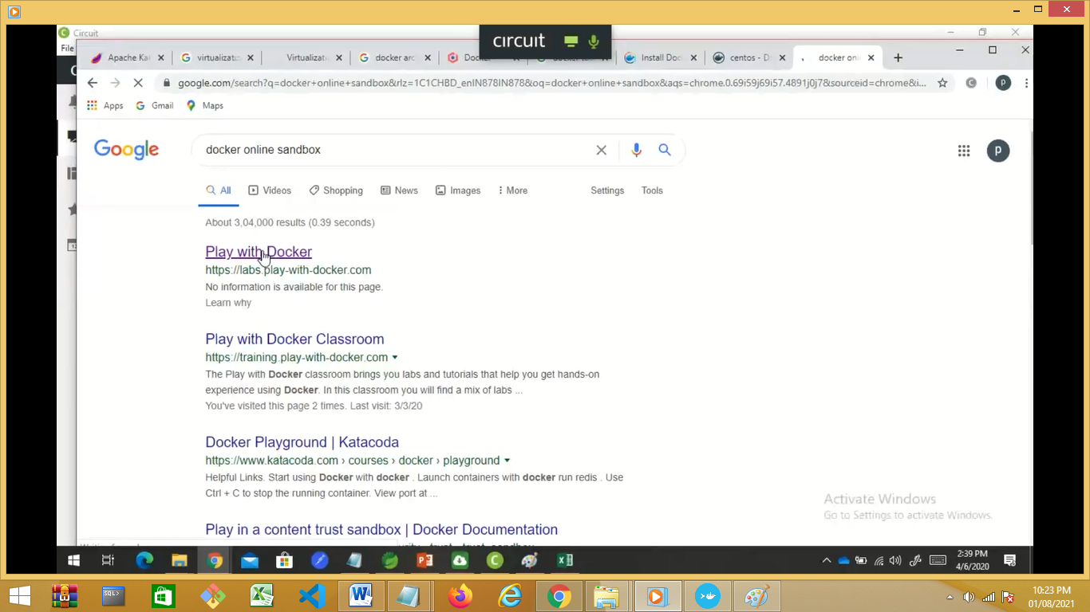

<https://labs.play-with-docker.com/>

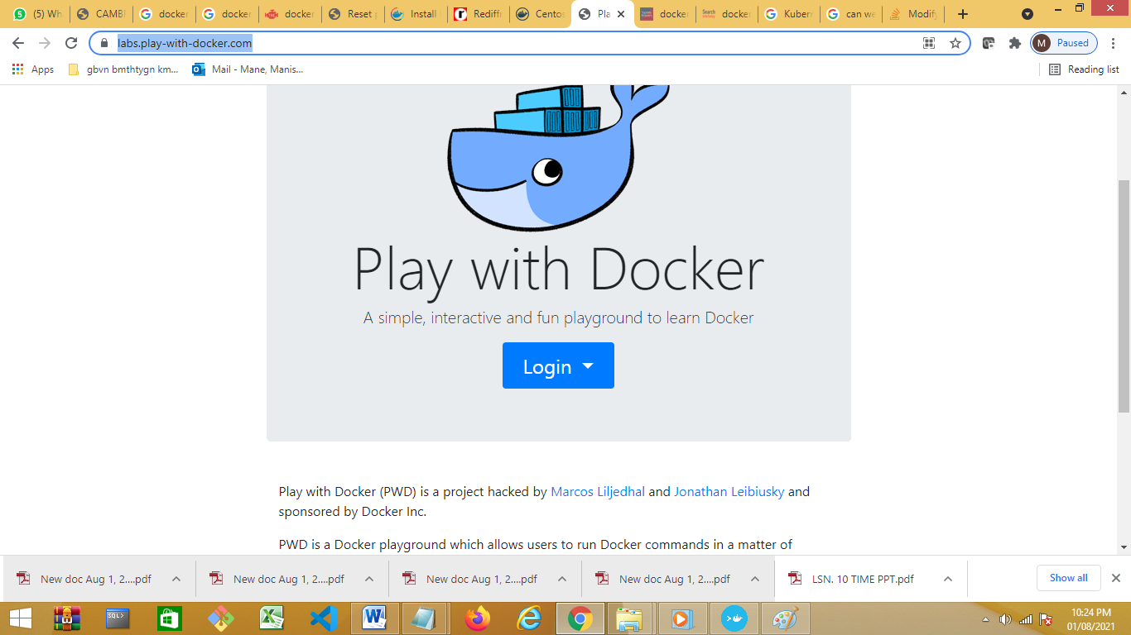

Login with docker hub credentials.

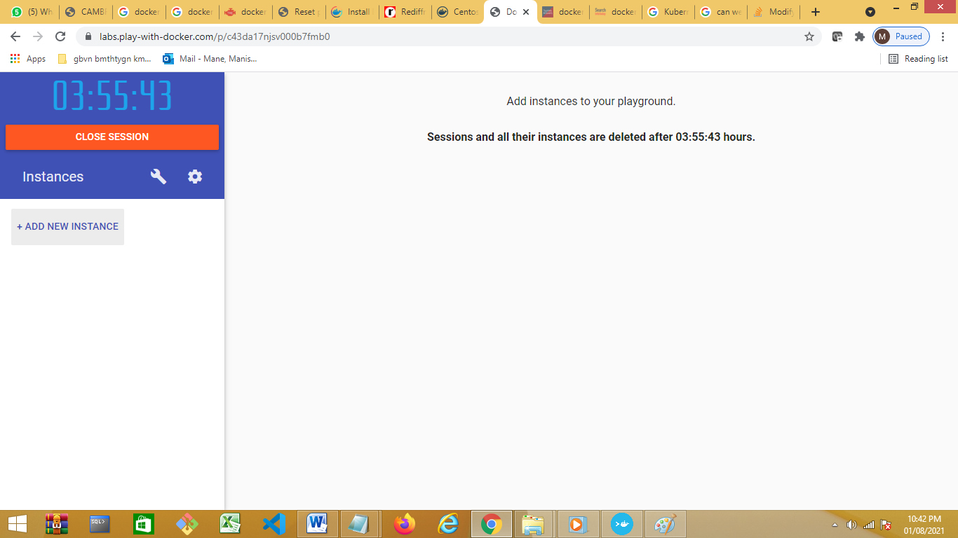

Add new instance –

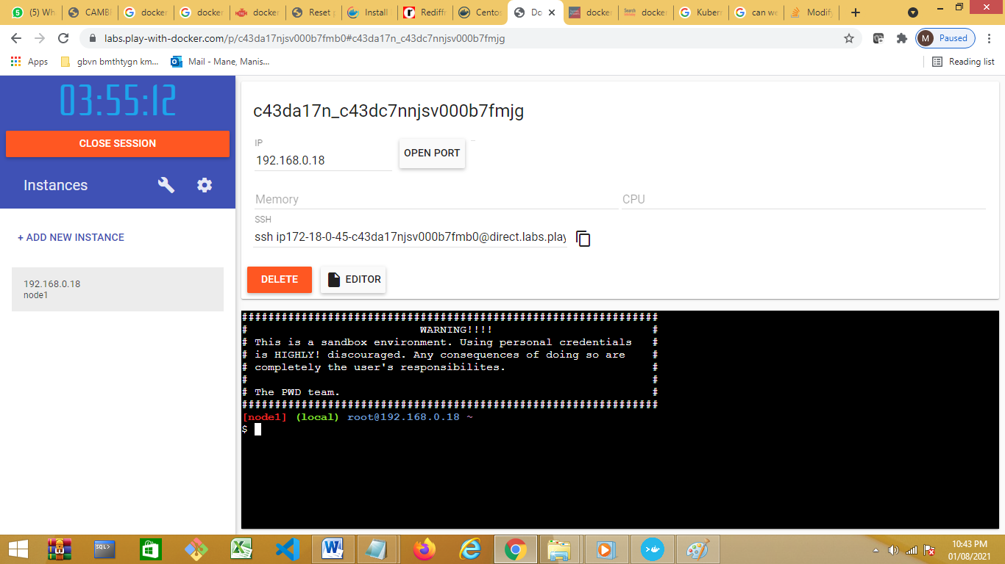

Check IP Address

Clear screen—

Commands:

Clear

Docker info

Clear

docker info--entire information

docker version

docker --version

docker -v

docker images

docker ps-- to see the containers

docker pull centos

will pull image from docker hub and download on host machine.

How to check the lates veriosn of image

1. Goole –dockre Ubuntu image
2. 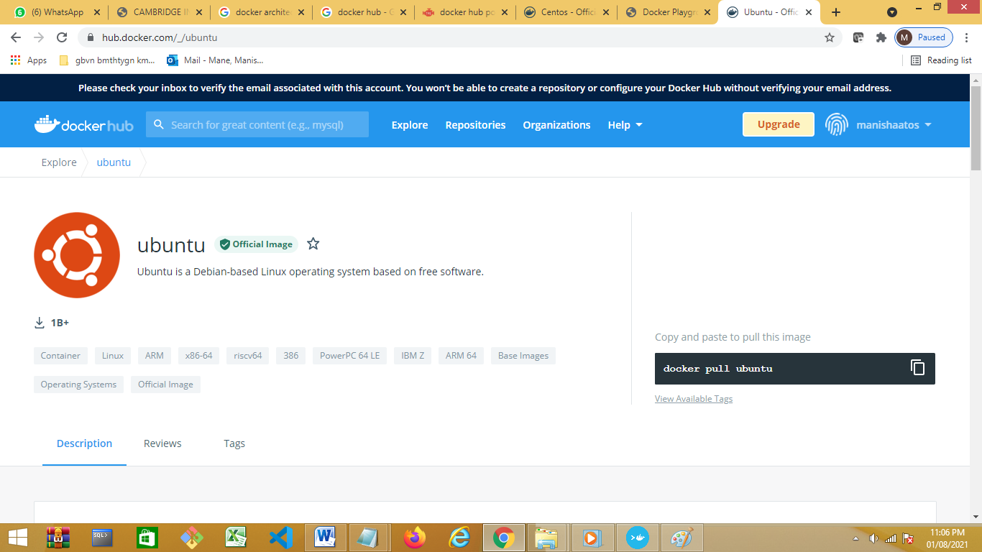

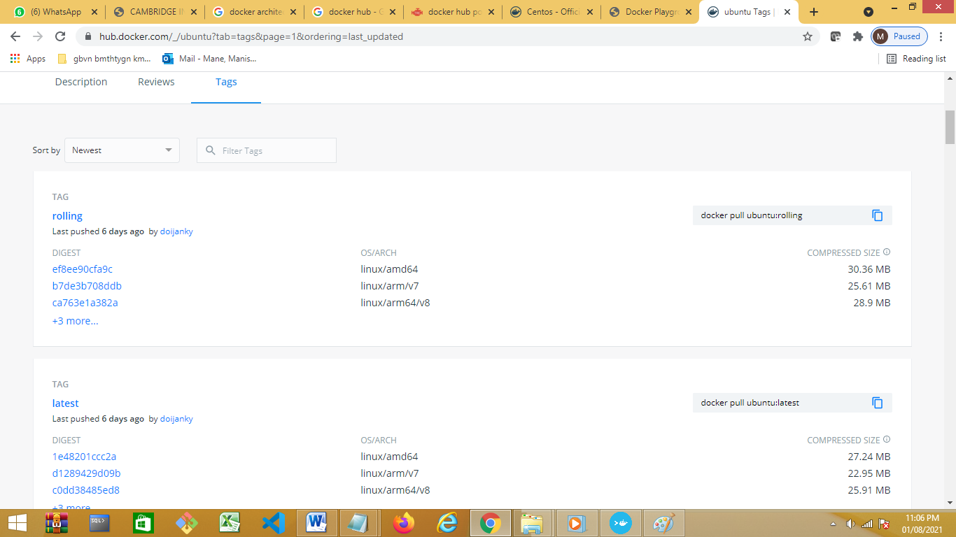

Download specific version

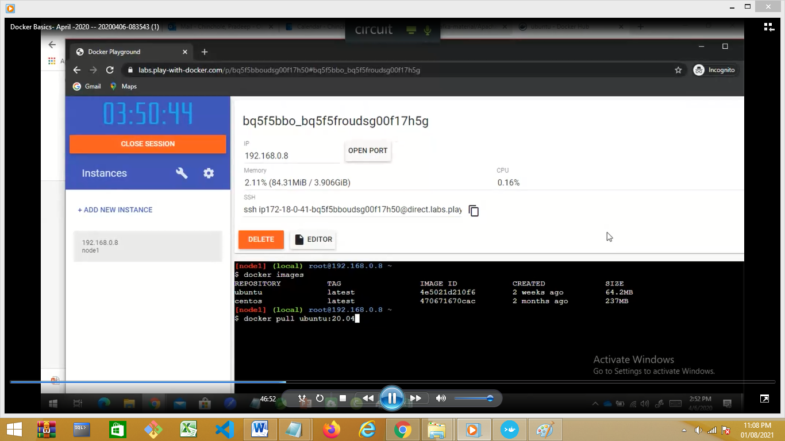

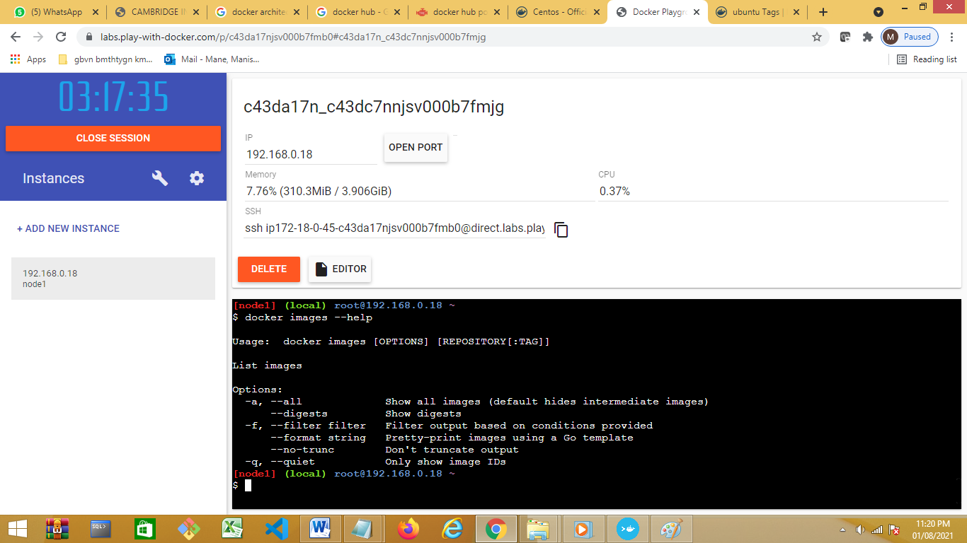

creating containers from images:

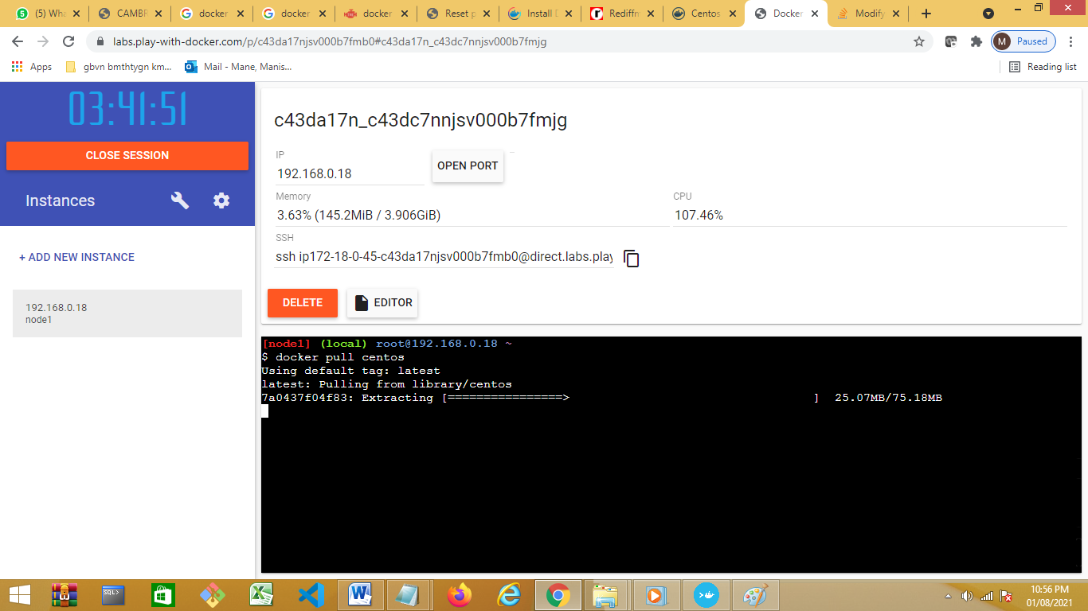

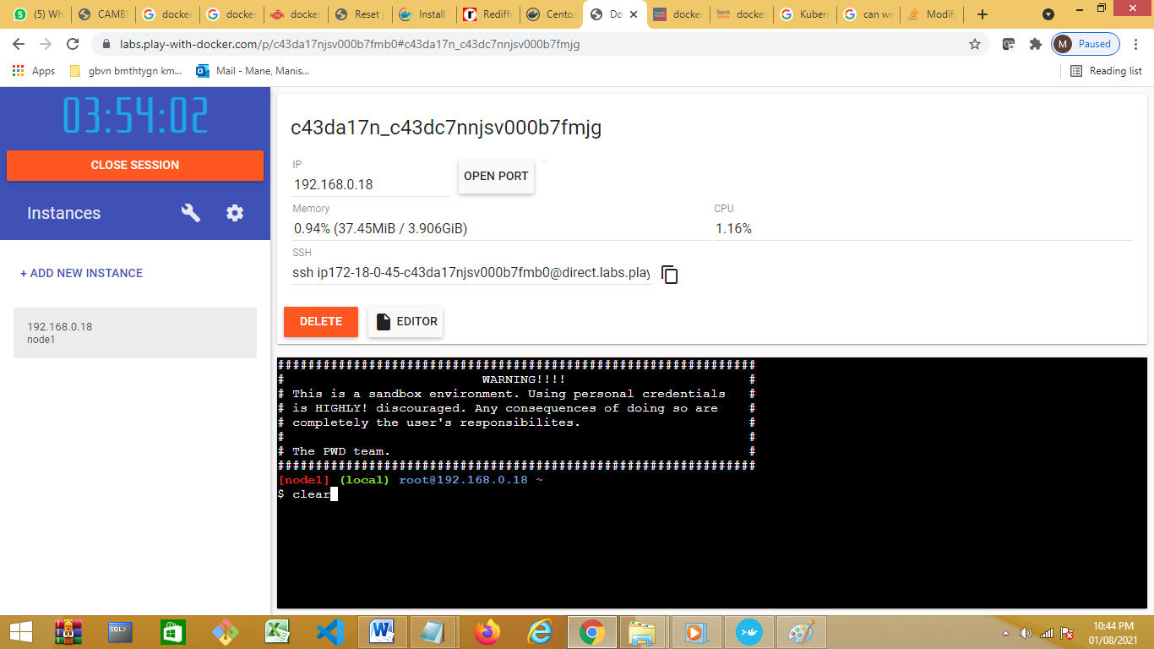

**Command to create container** –container is running instance of an image , 1 image 1 container

Docker run Ubuntu if we run same command 3 times ,3 container will get created , use docker info to check . we can create n no of container from an image as such no limit.

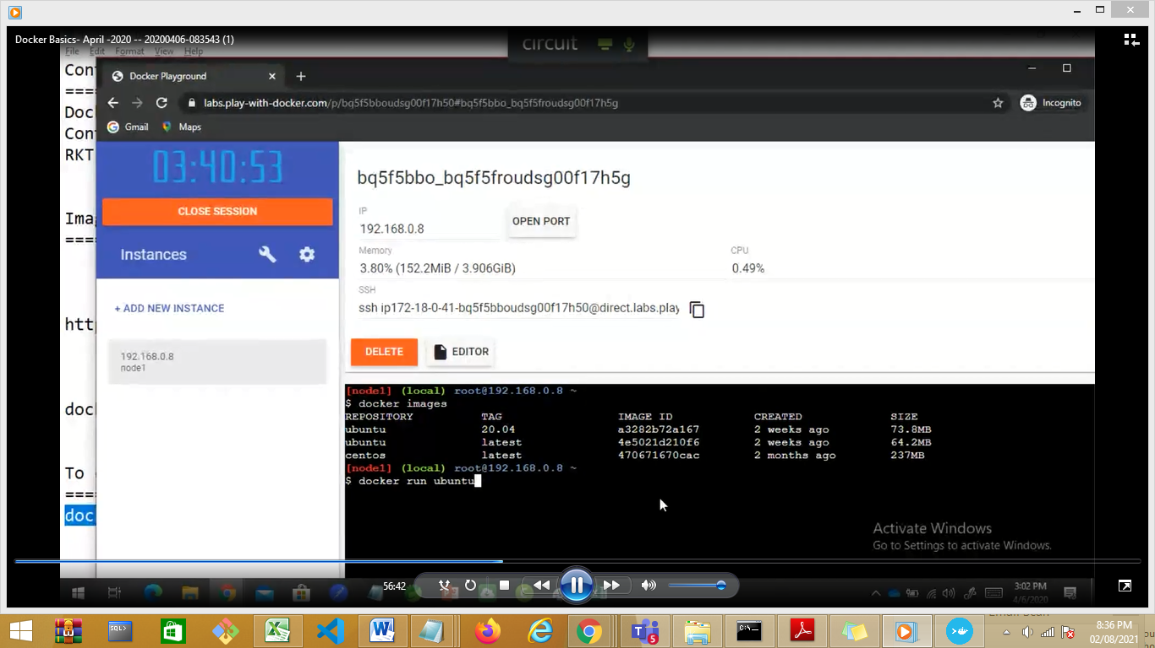

Docker ps – will show running container

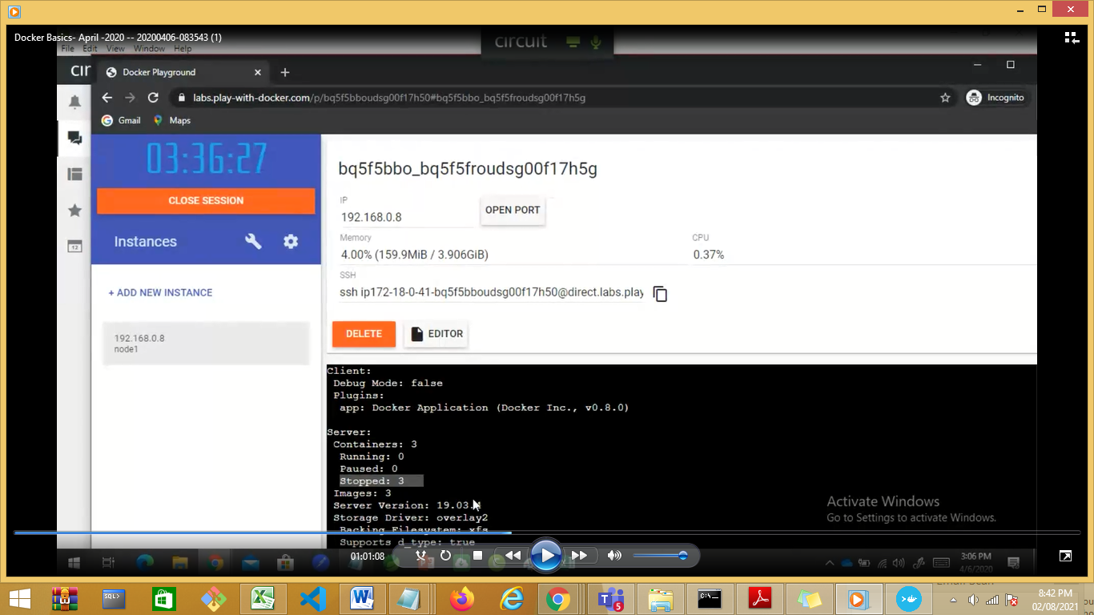

Docker ps –a (all container ,running ,stopped,paused

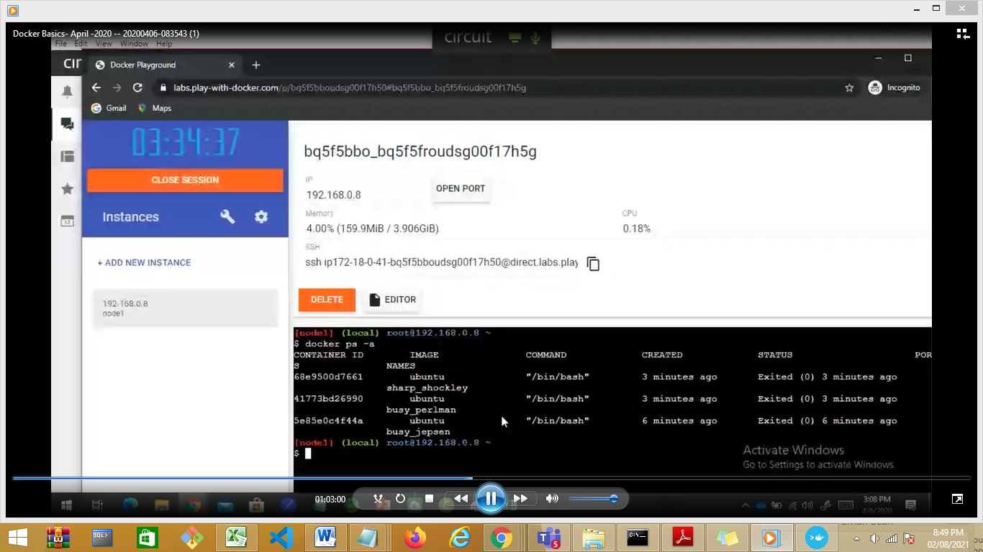

Dynamically for every container a naem is assigned . we can give name as per our requirement.

Docker run –name <myname> Ubuntu.

If we give same to the containers then there will be collision .

Run the container in interactive mode

Docker run --name myname -it Ubuntu “bin/bash”.

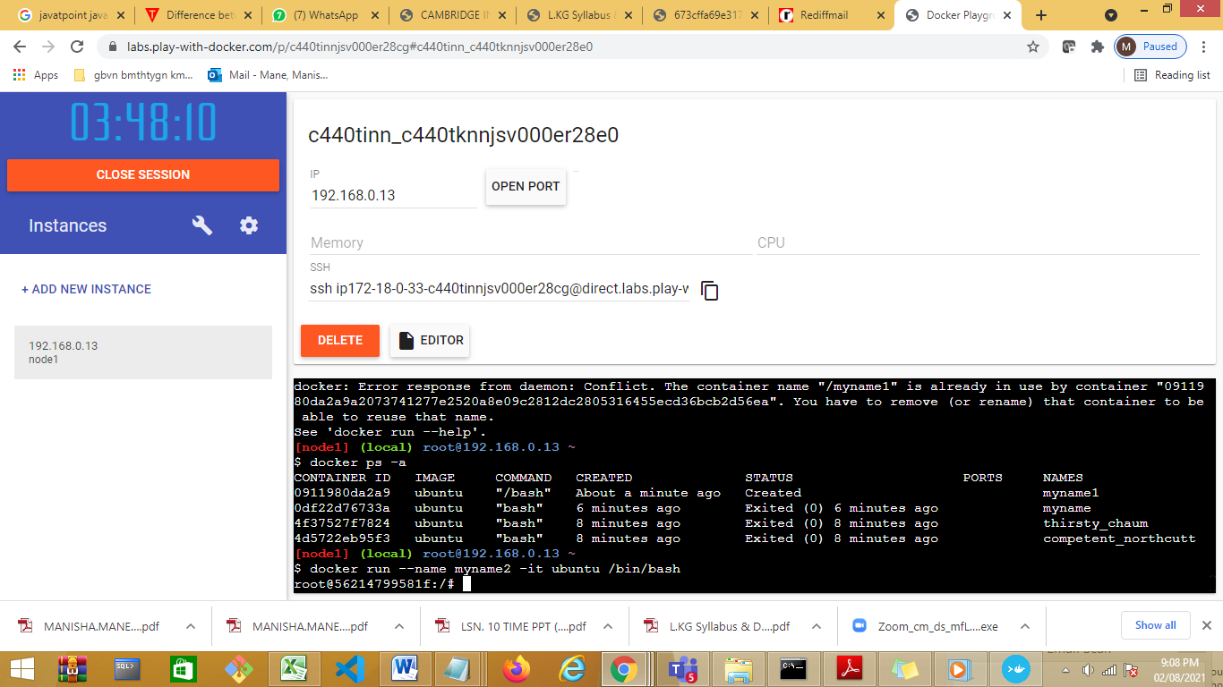

Started wth linux terminal : we can run linux commands

To exit a container.

Exit

**To start and stop container**

: doker start --help

: docker start -i <container-name> To start the stoped container

: docker stop <container-name> To stop running container

: docker logs <container-name> To sess logs of contianer

: docker exec -it <container-name> bash To interact with container

Show all basic commgithub.com/pradeep82/docker-repository

Docker run--. Docker start and docker exec –find difference

Image location :

https://www.freecodecamp.org/news/where-are-docker-images-stored-docker-container-paths-explained/

Day 2:

Add new instance

Containerization :

App3

App2

App1

Day 1

Libs/Bin

Libs/Bin

Libs/Bin

Container Engine

Operating System

Infrastructuer(HDD, CPU, RAM,MONITOR)

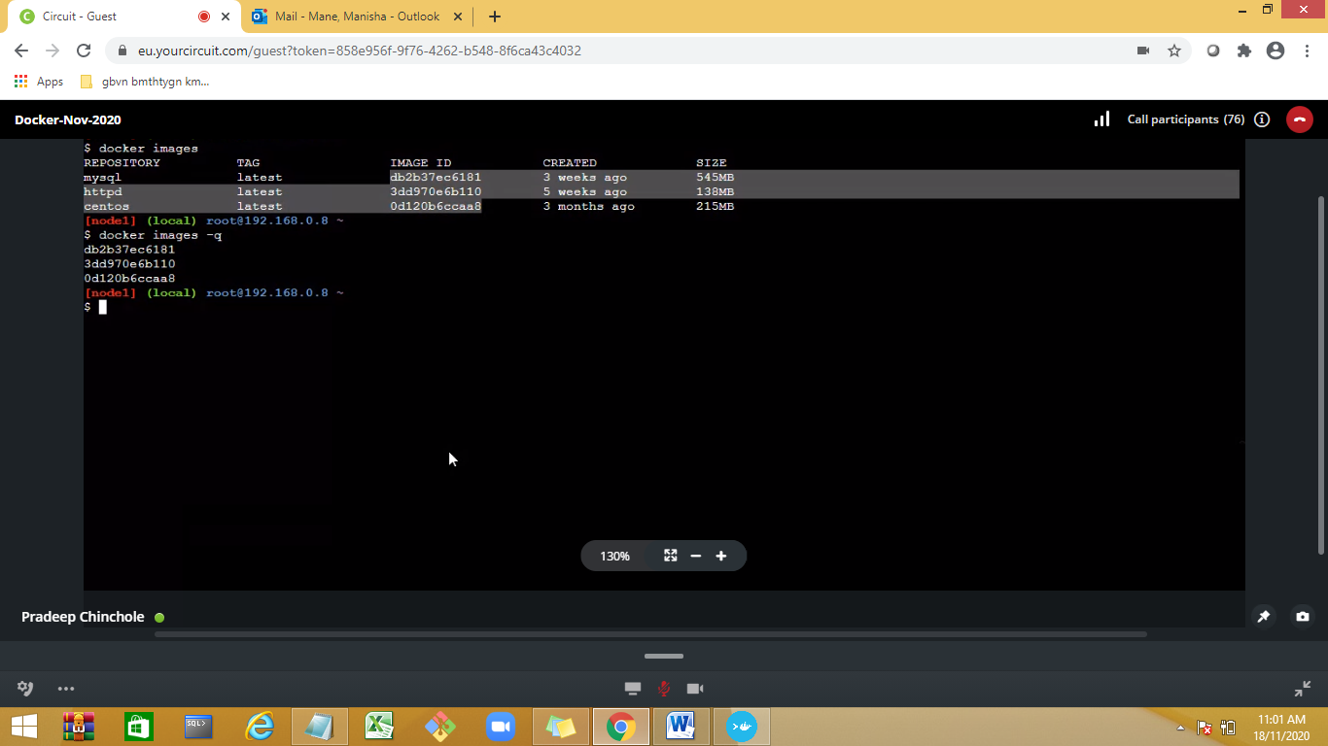

[Type a quote from the document or the summary of an interesting point. You can position the text box anywhere in the document. Use the Drawing Tools tab to change the formatting of the pull quote text box.]

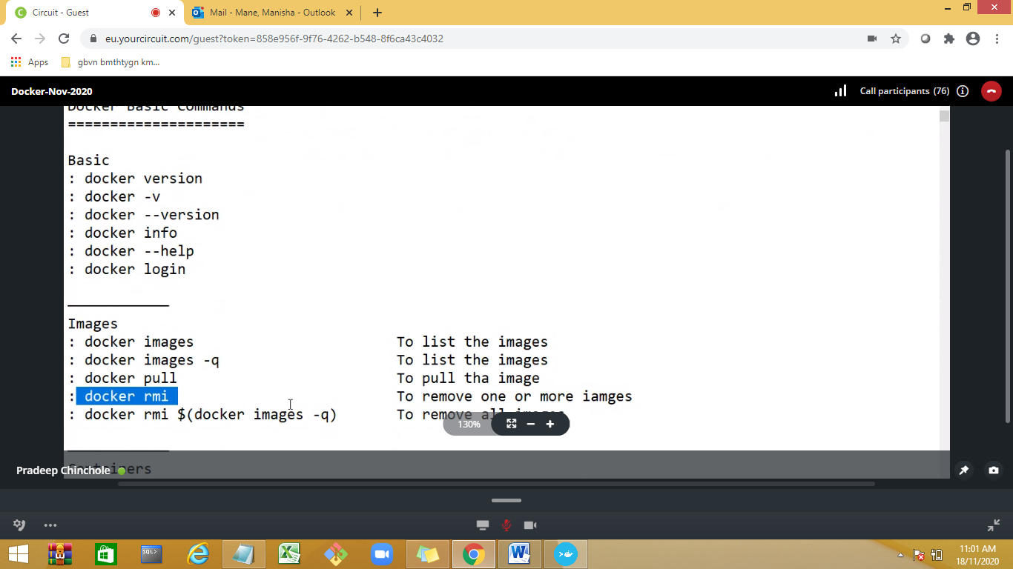

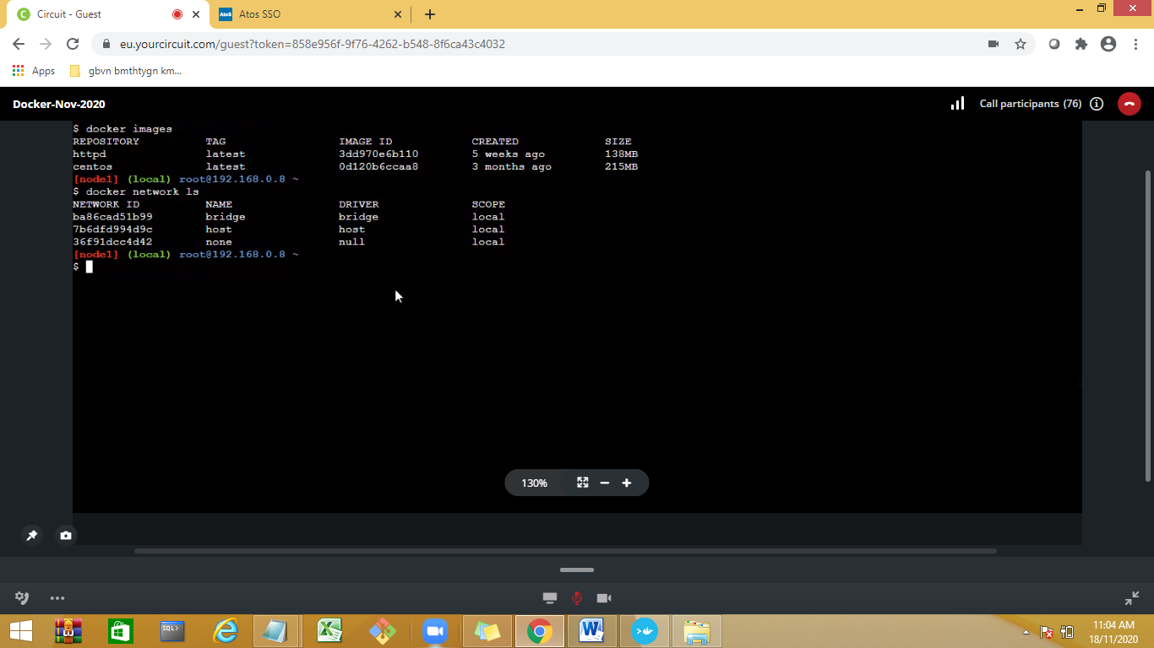

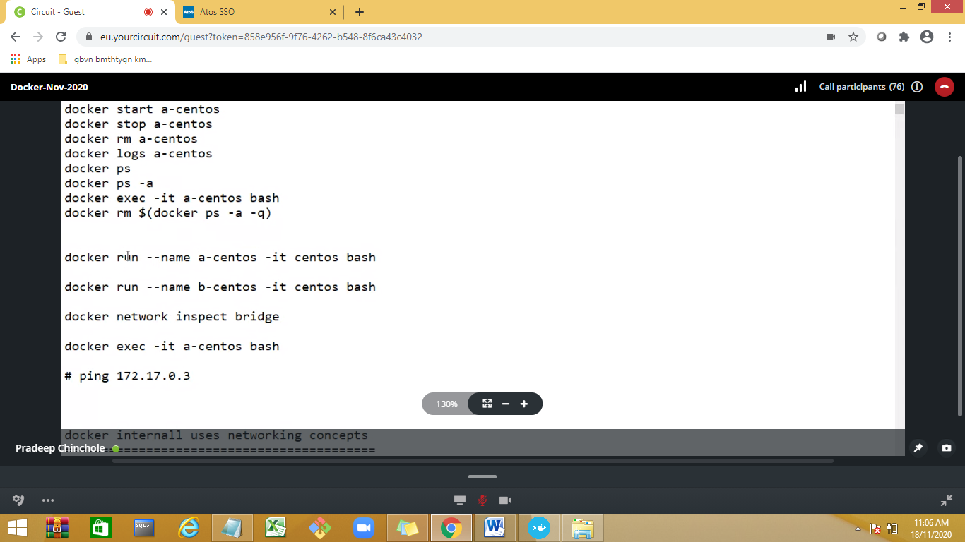

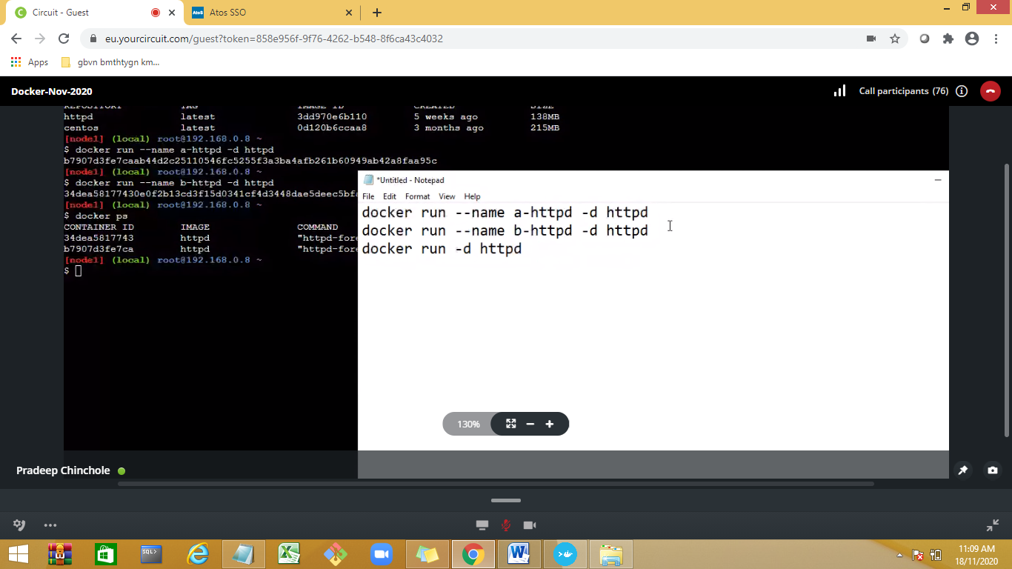

Creating container for httpd (lightweight server)image

2 modes

Intercative

detached—no logs for container

docker run –name a-httpd –d httpd

a-hhtpd –container name

if we don’t specify name of container docker will assign a name

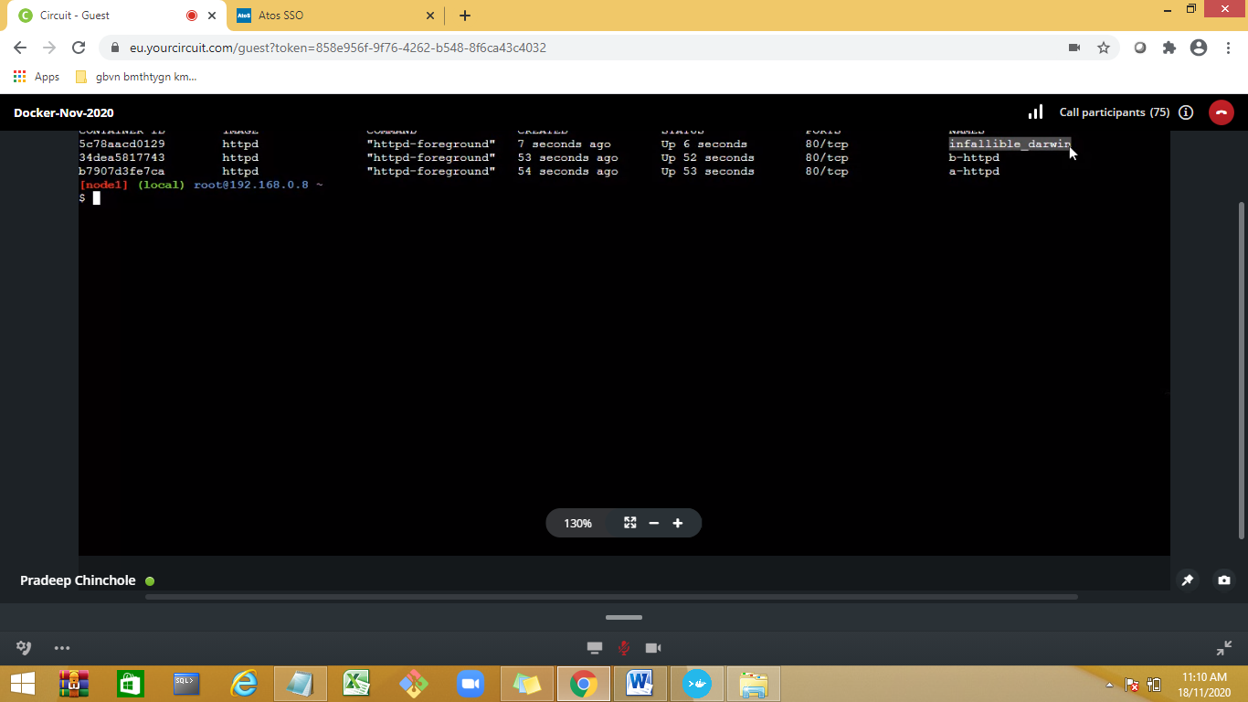

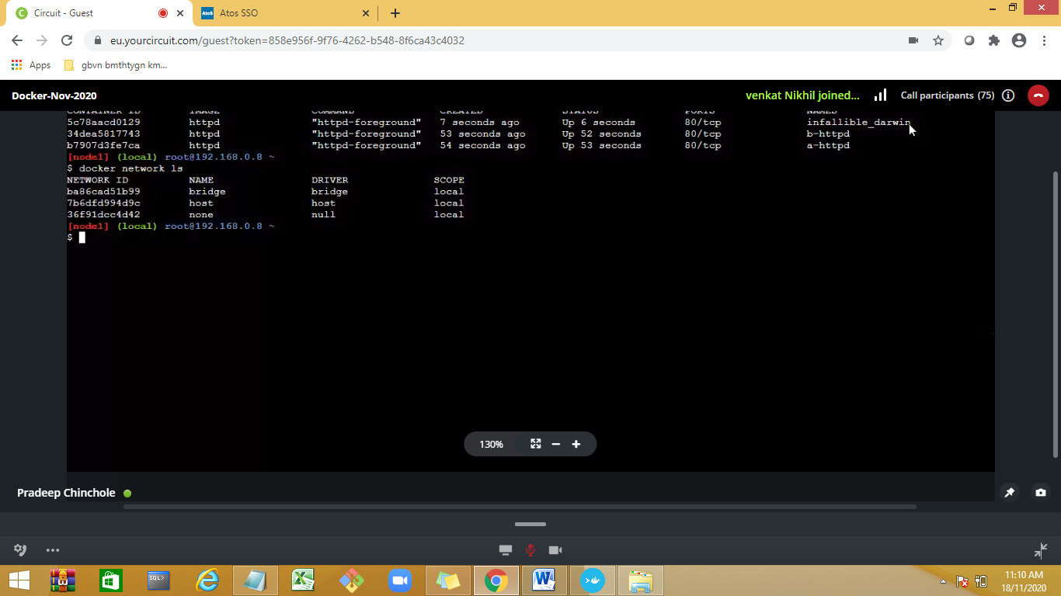

3 network defaukt is bridge n/w

Docker network

inspect bridge

Docker ps—all running container

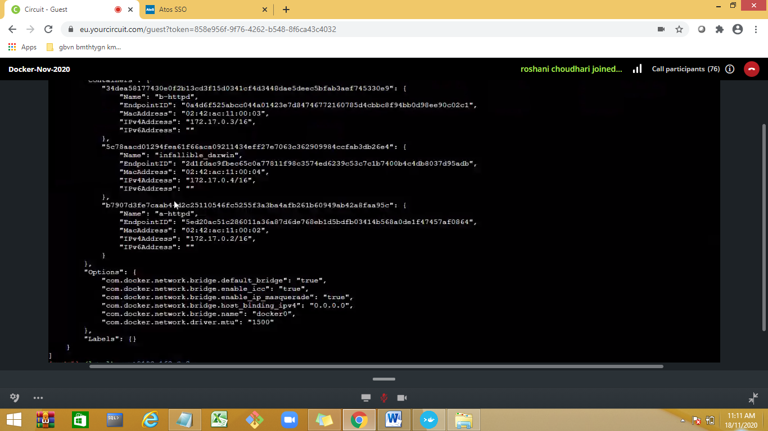

To stop

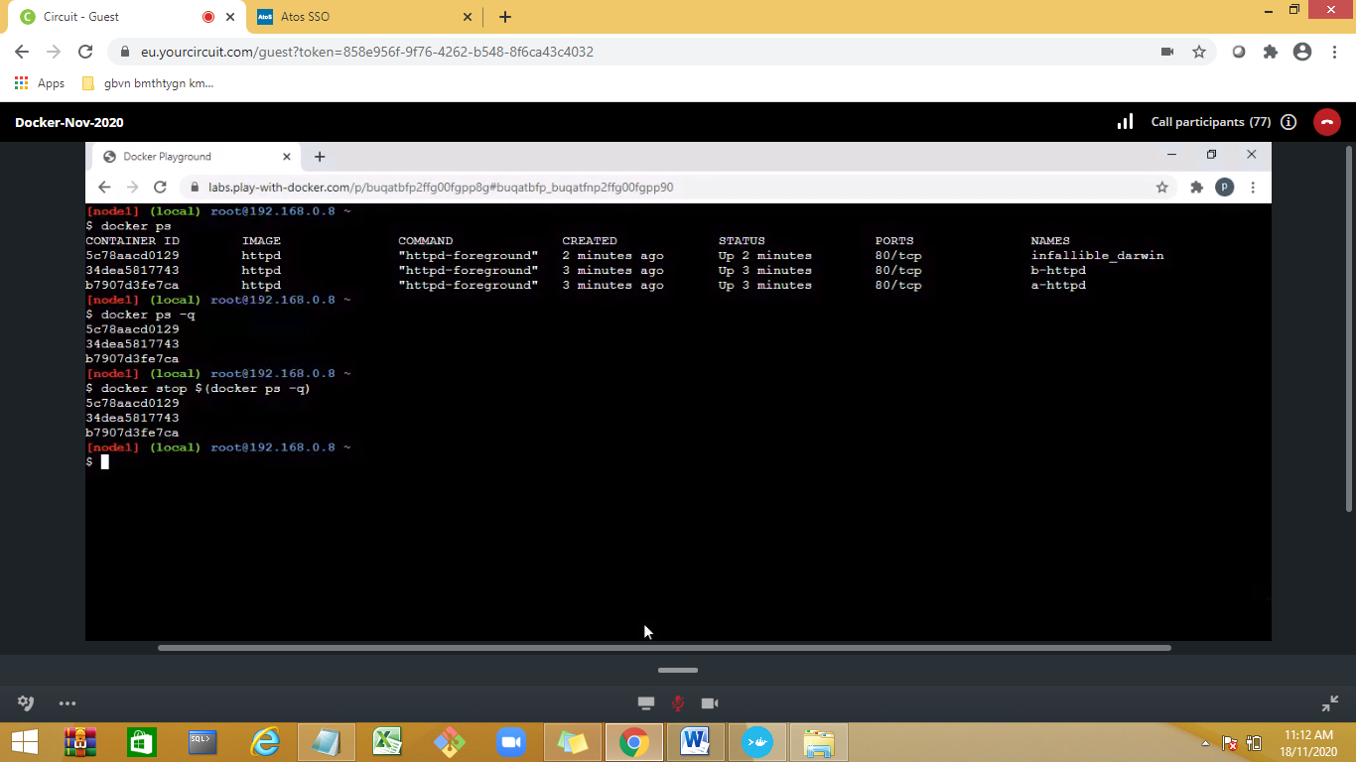

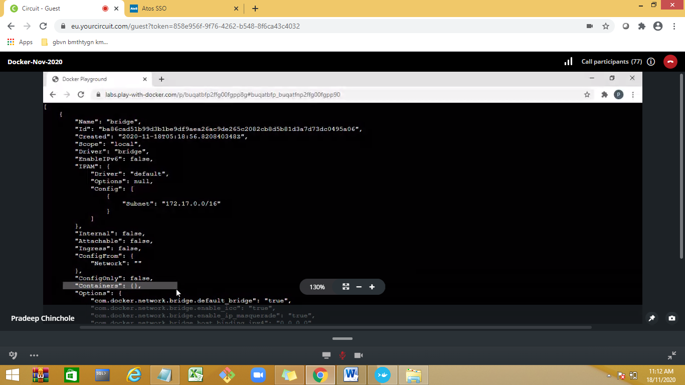

To view stopped container

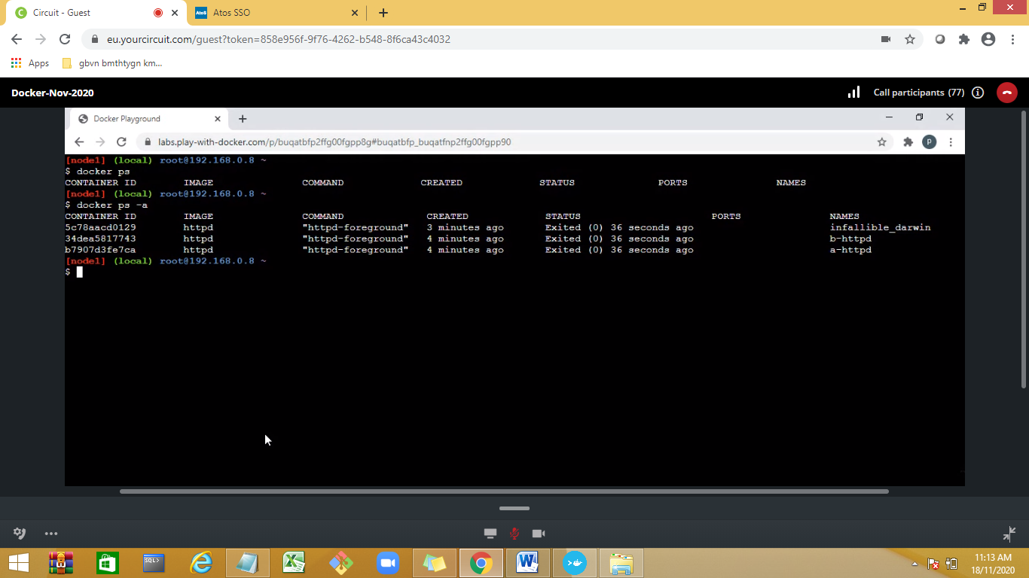

Run🡪to create a container

Start—to start

Stop—to stop

To view all stop container:

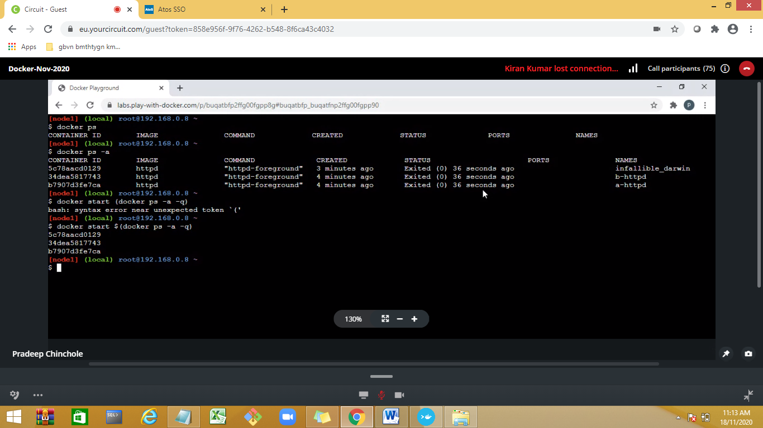

docker run -it <image-name> bash create a container from image in interactive mode

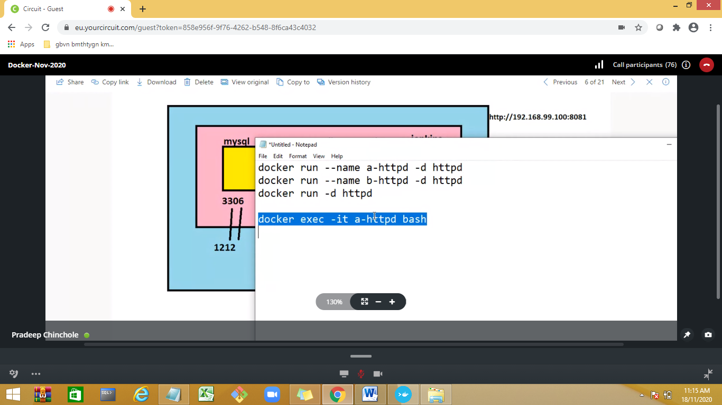

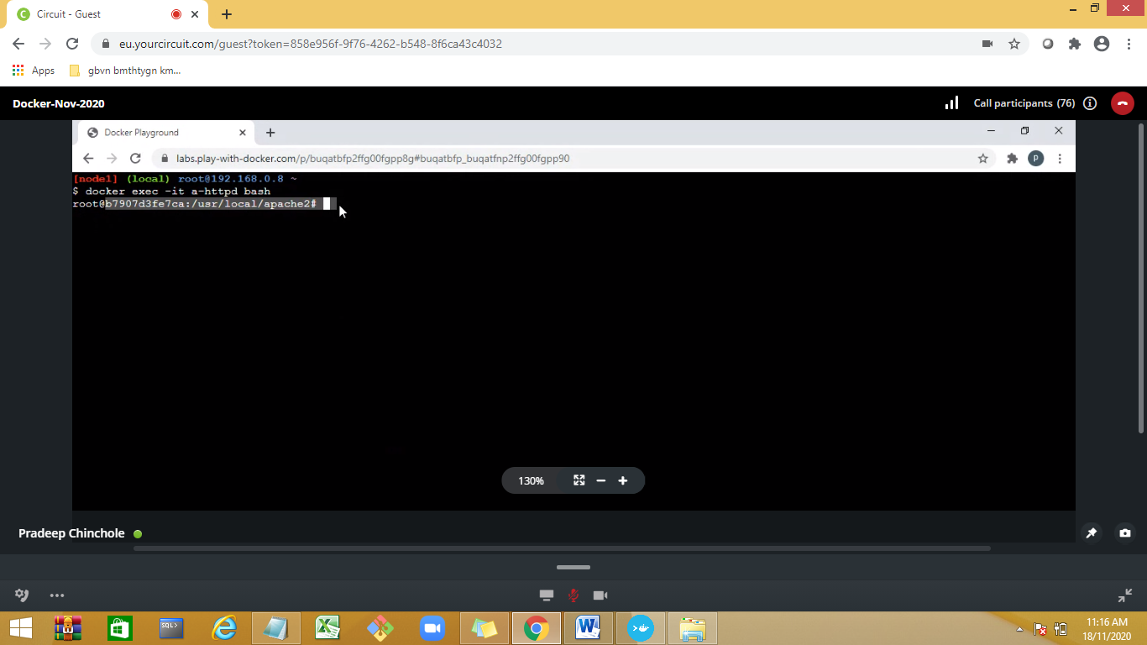

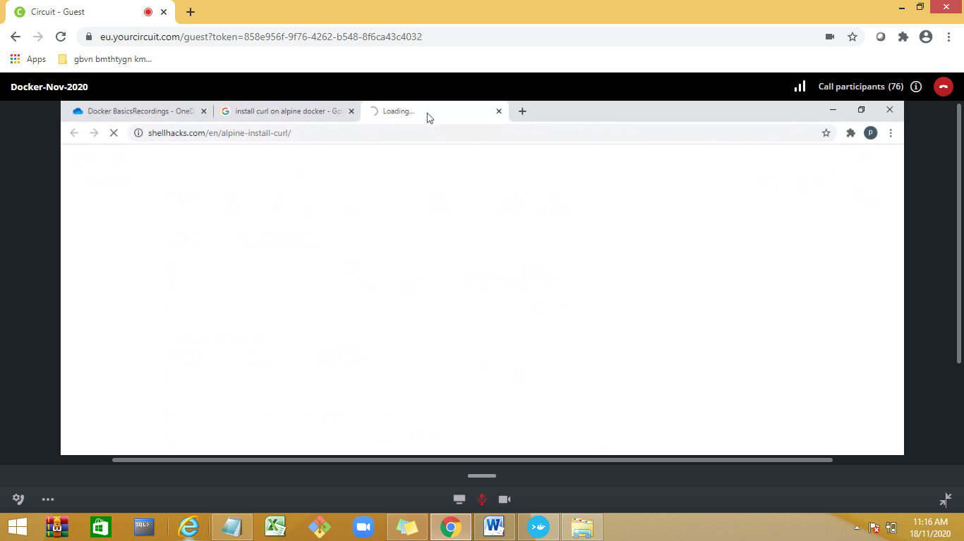

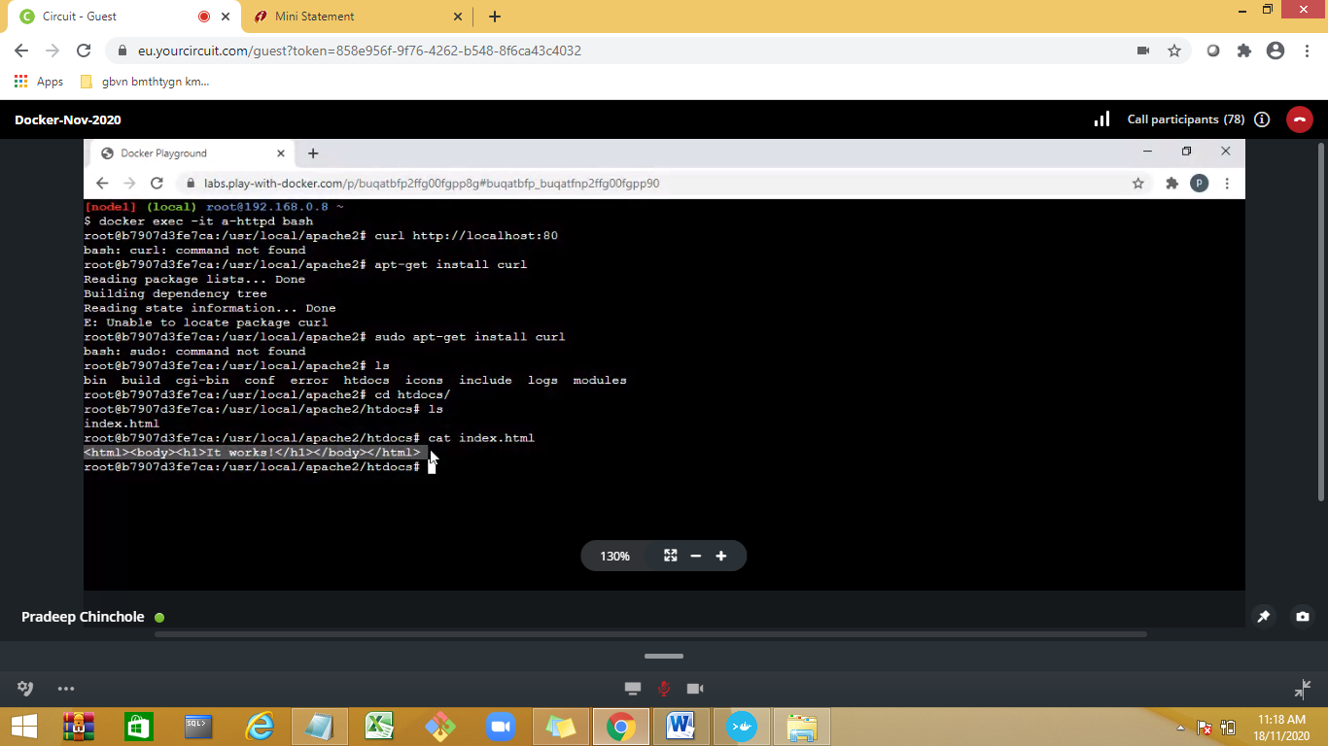

To change port number port forwardization

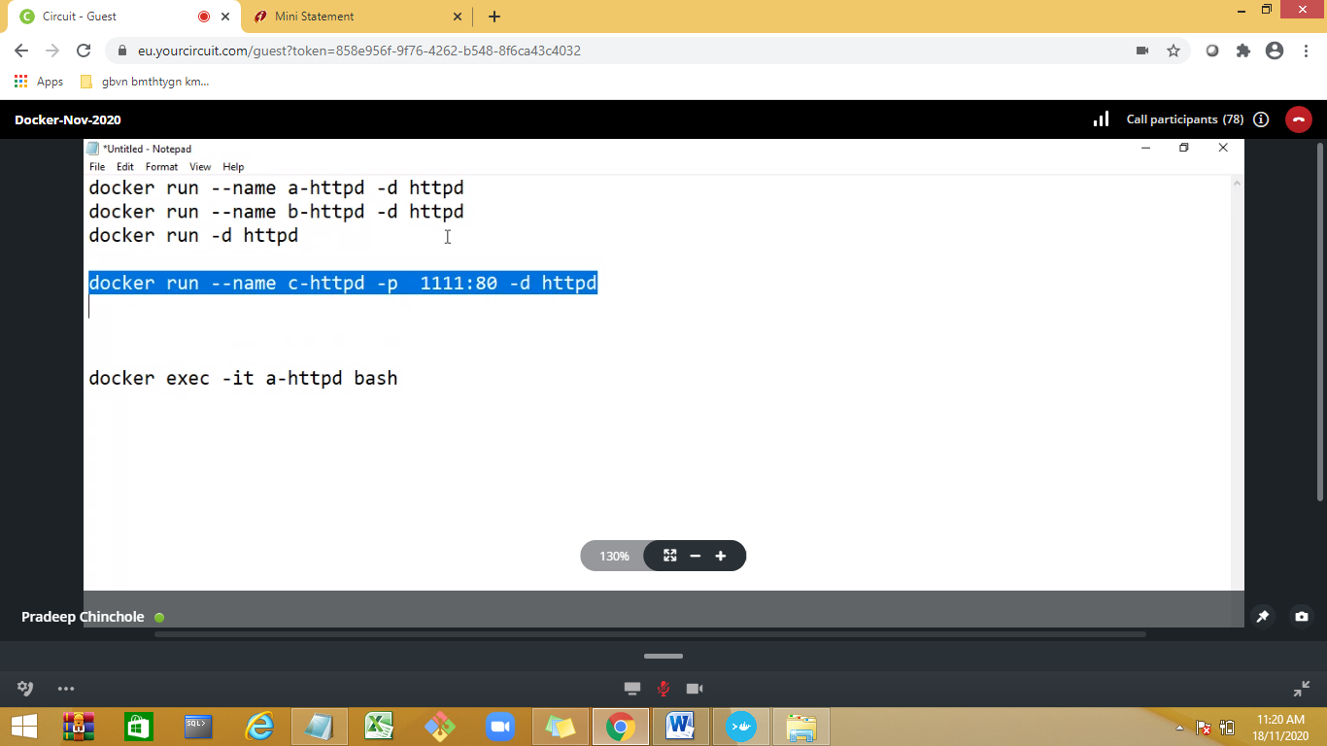

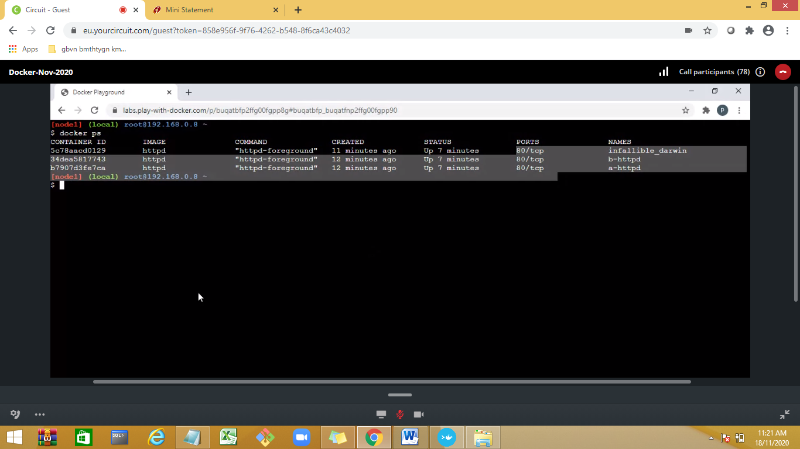

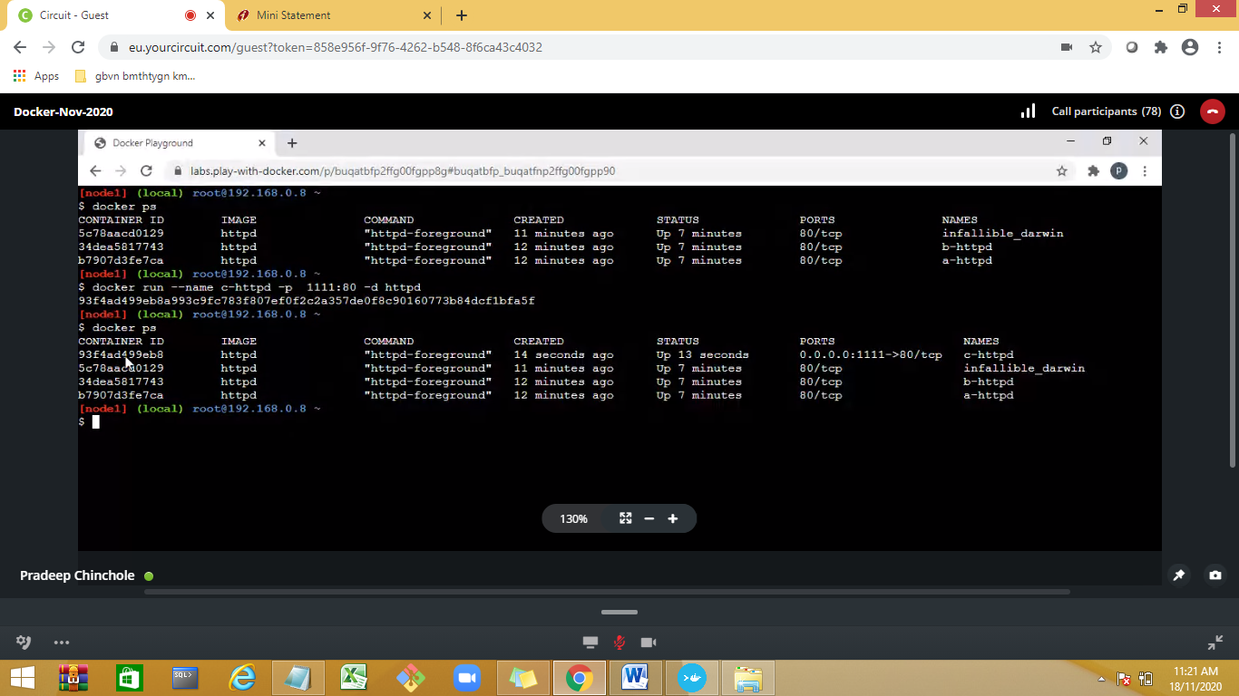

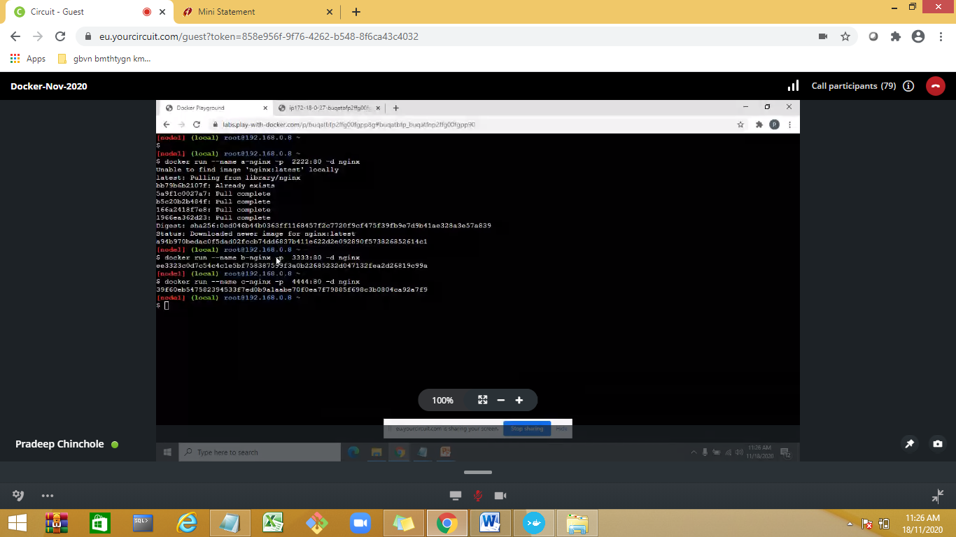

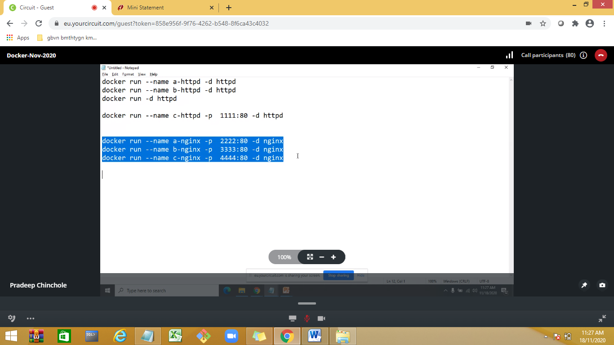

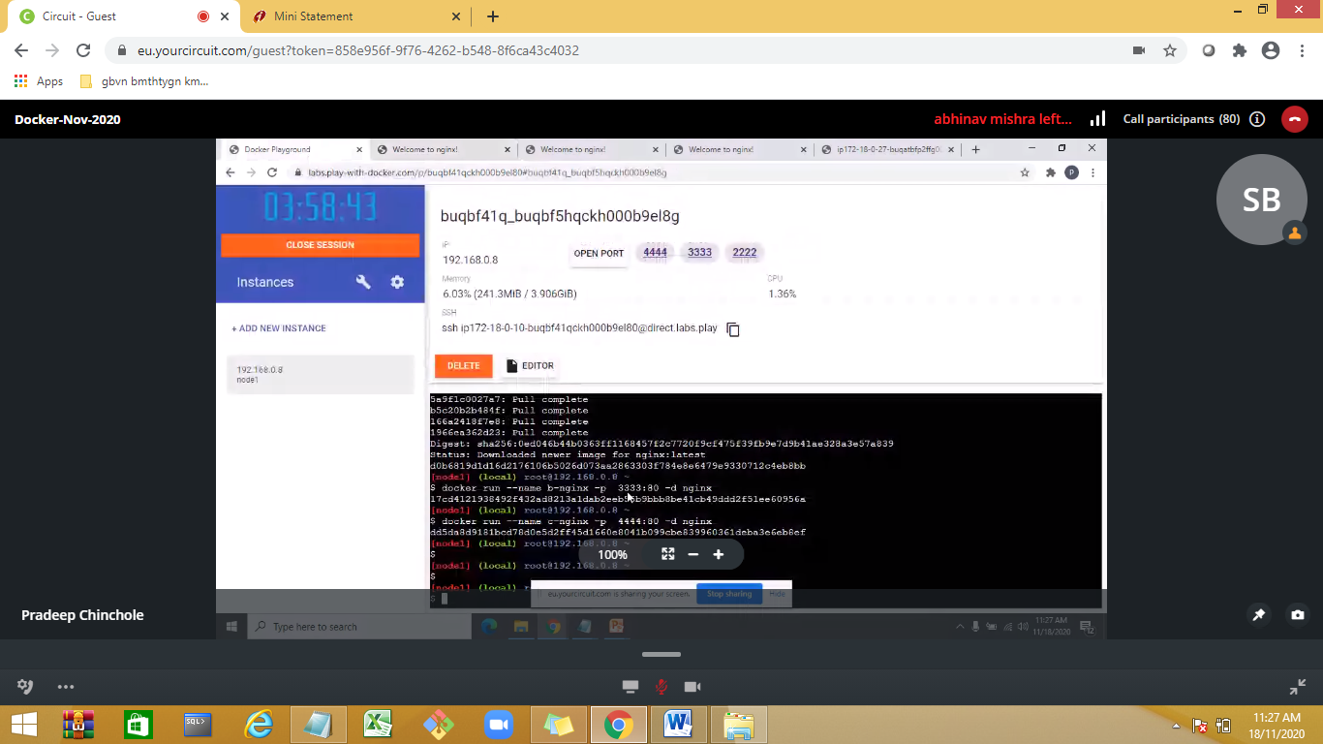

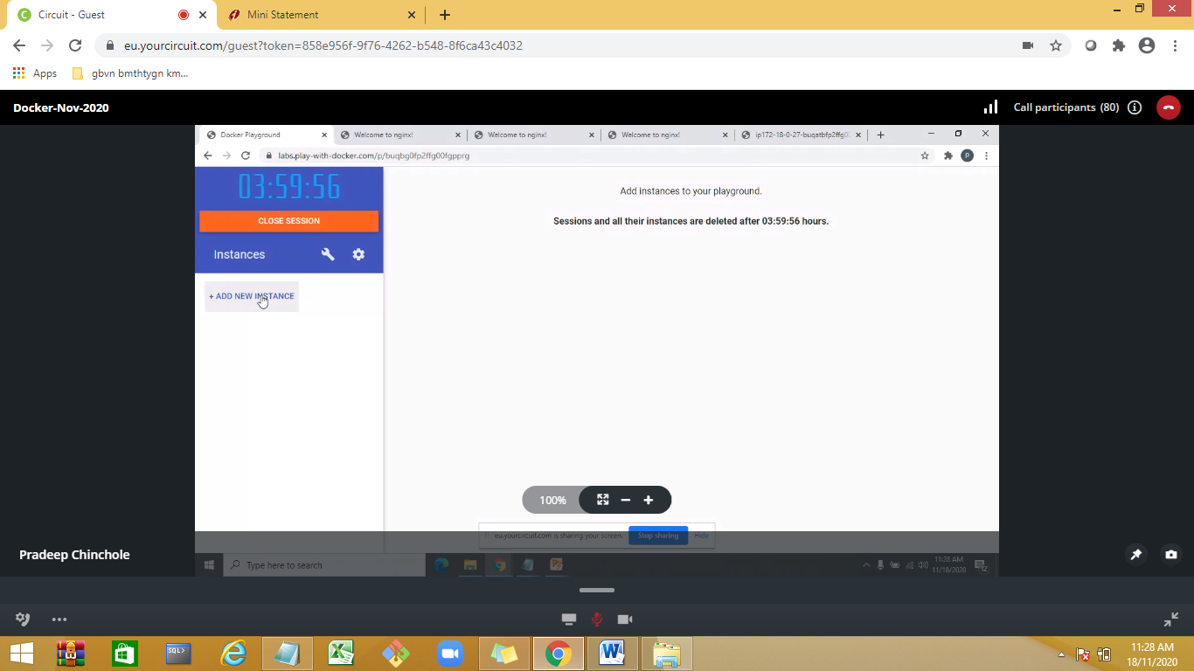

How to specify image version:

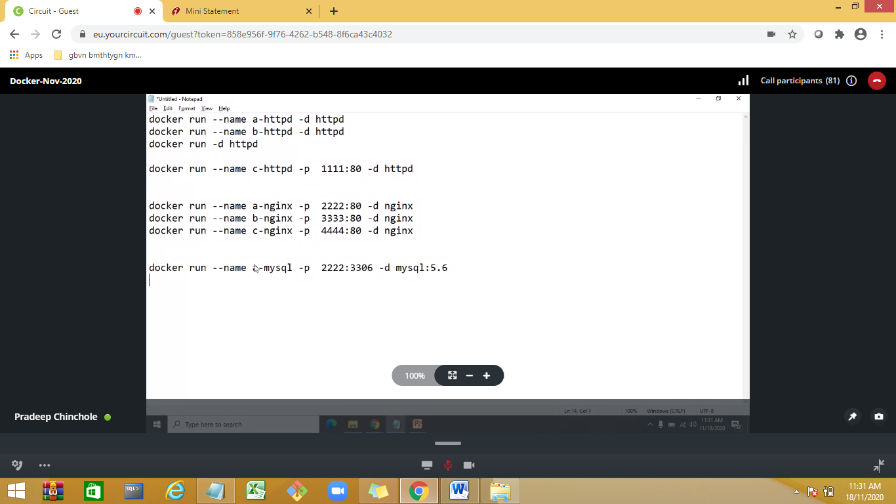

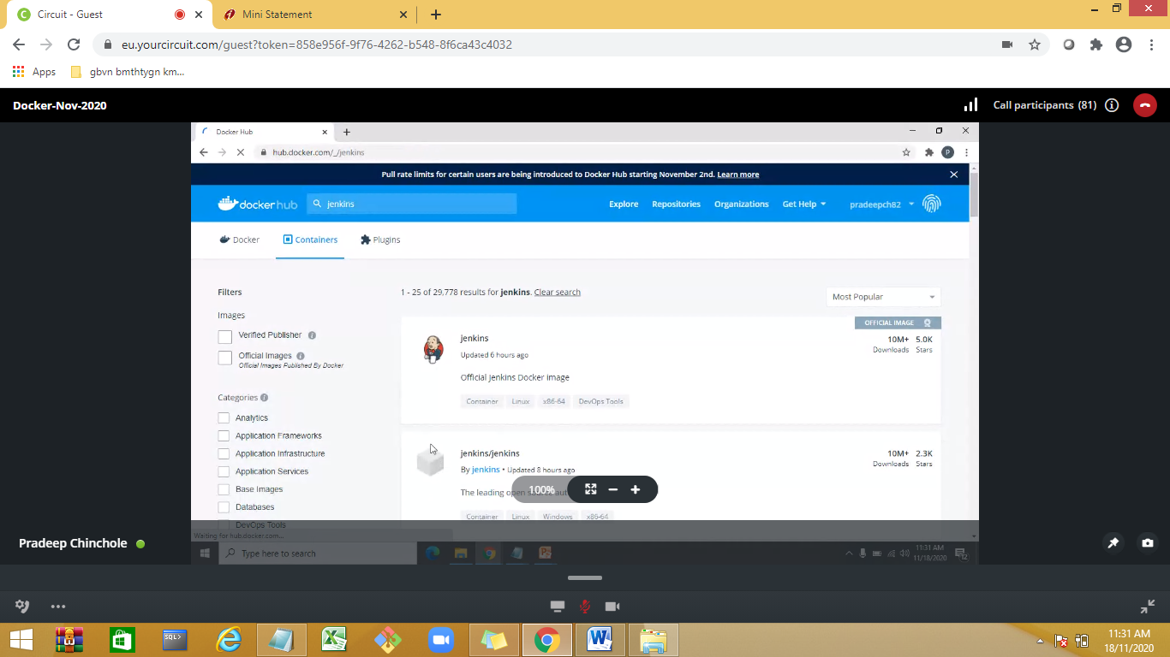

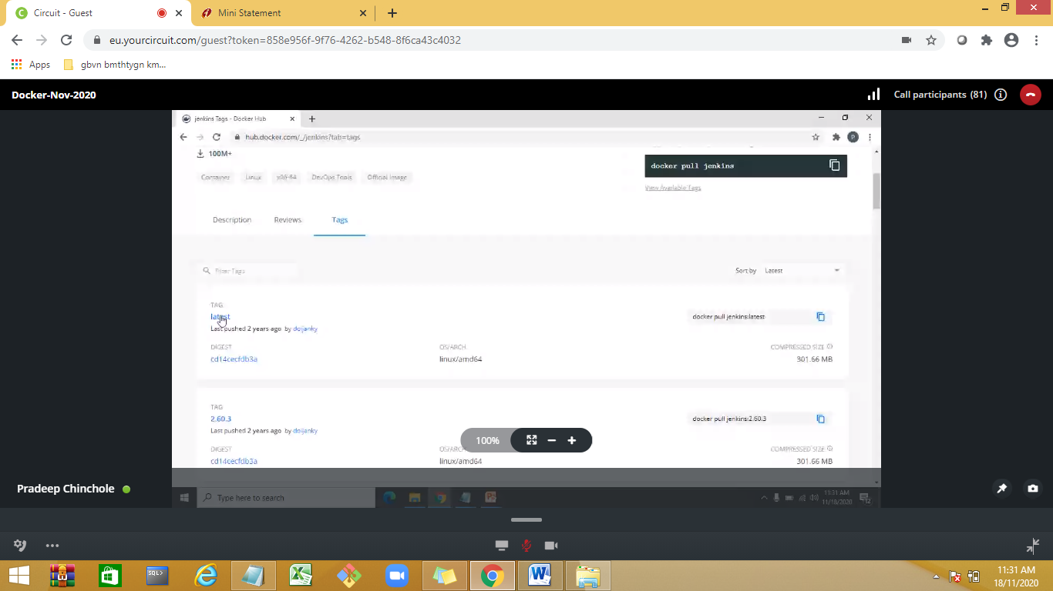

To get version details use tag

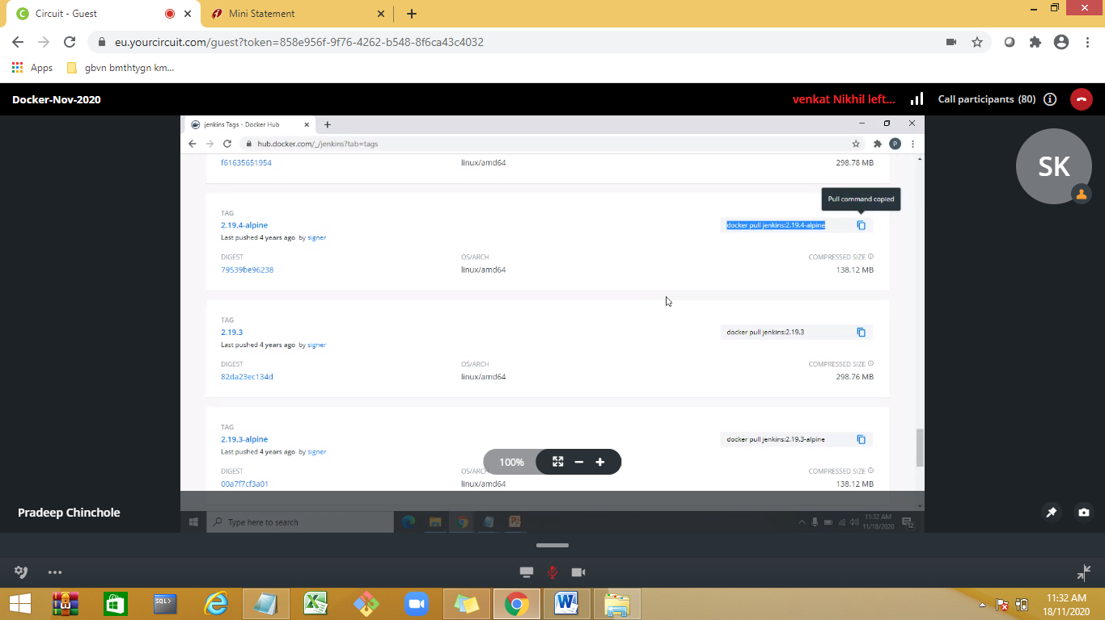

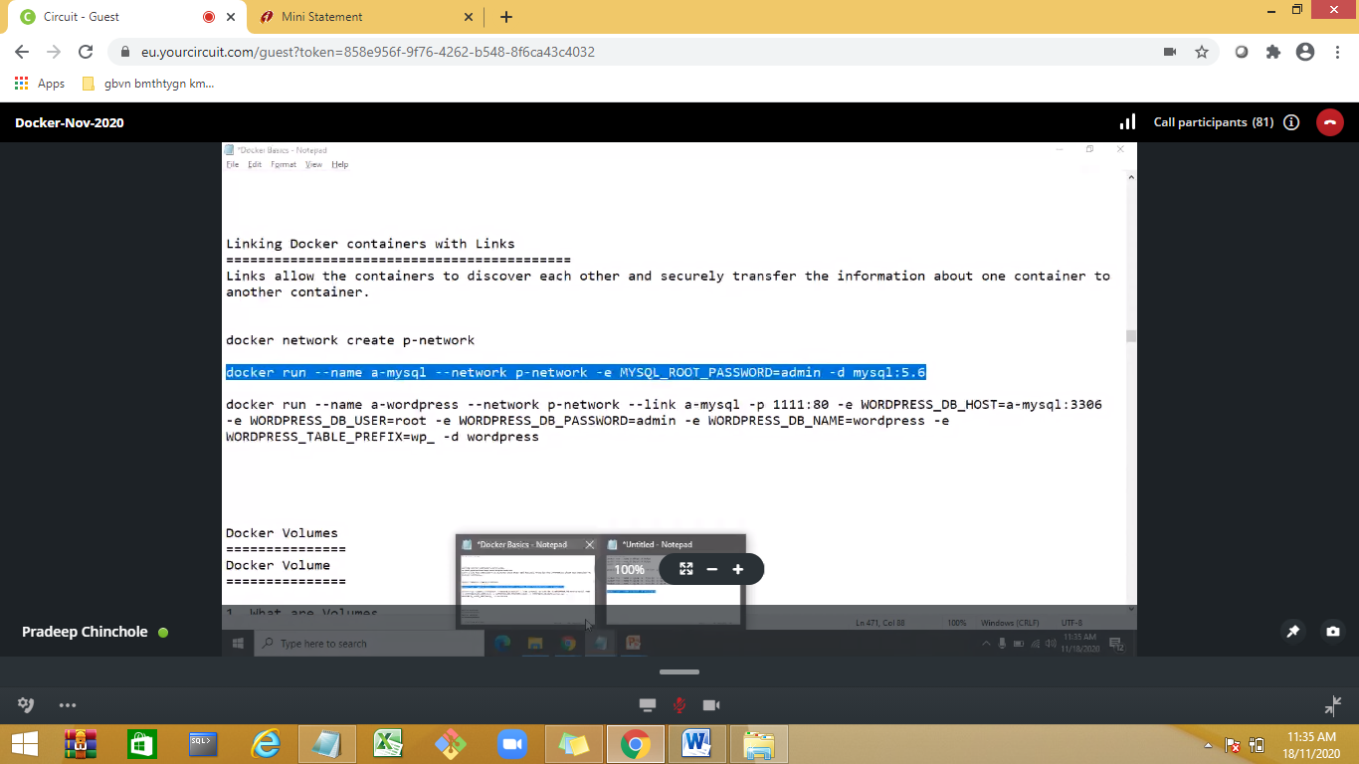

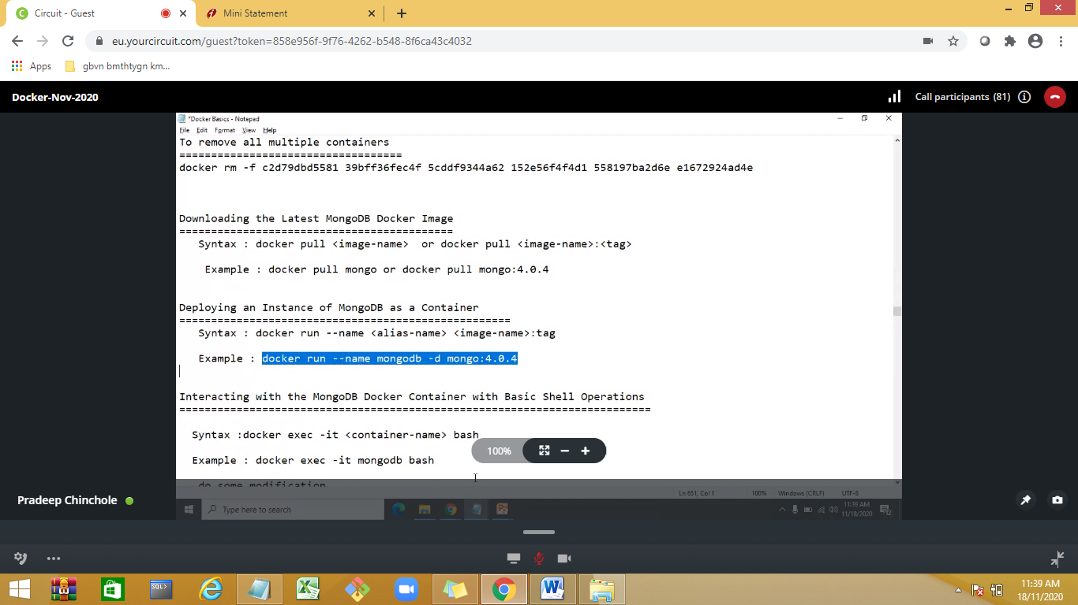

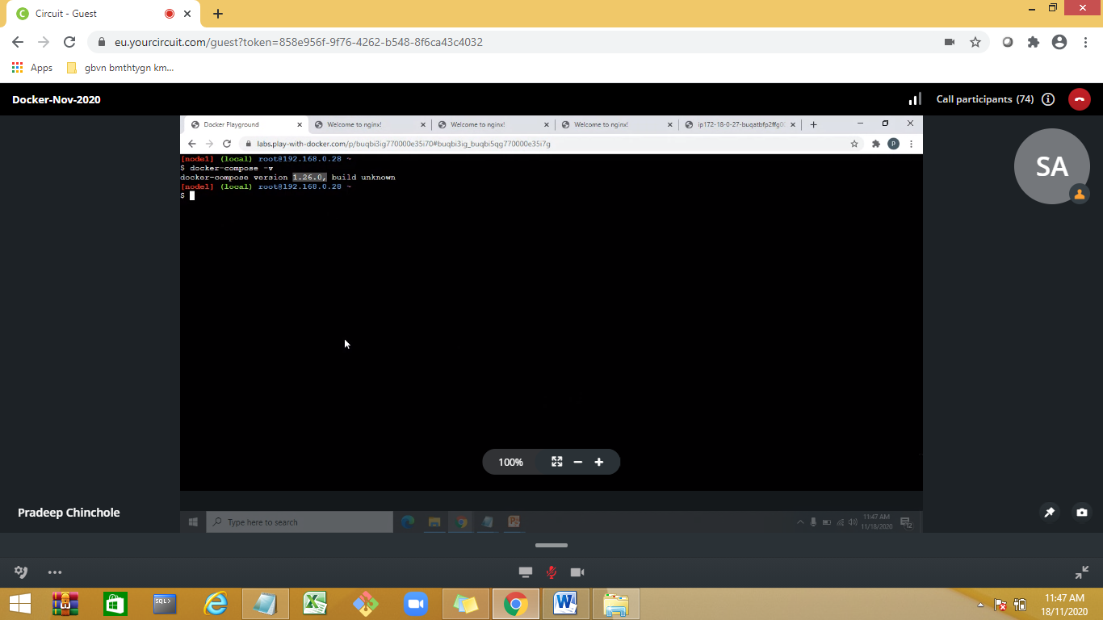

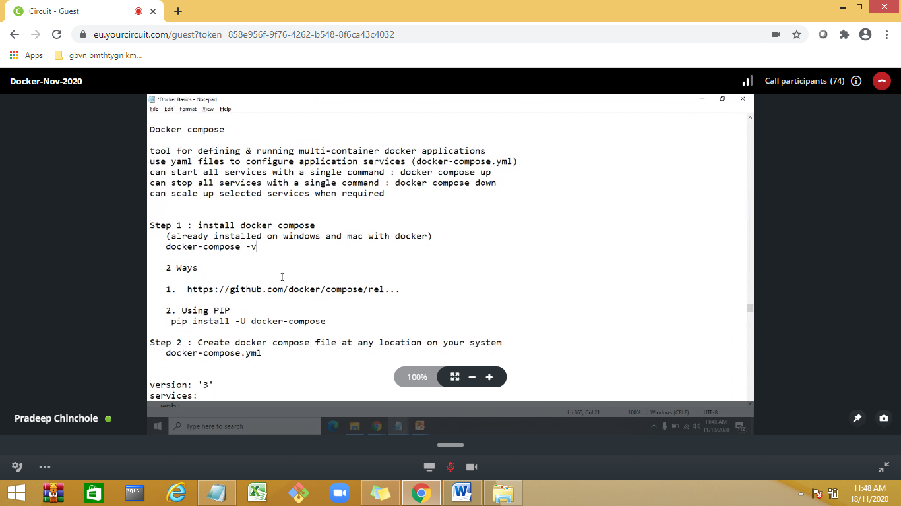

Docker compose

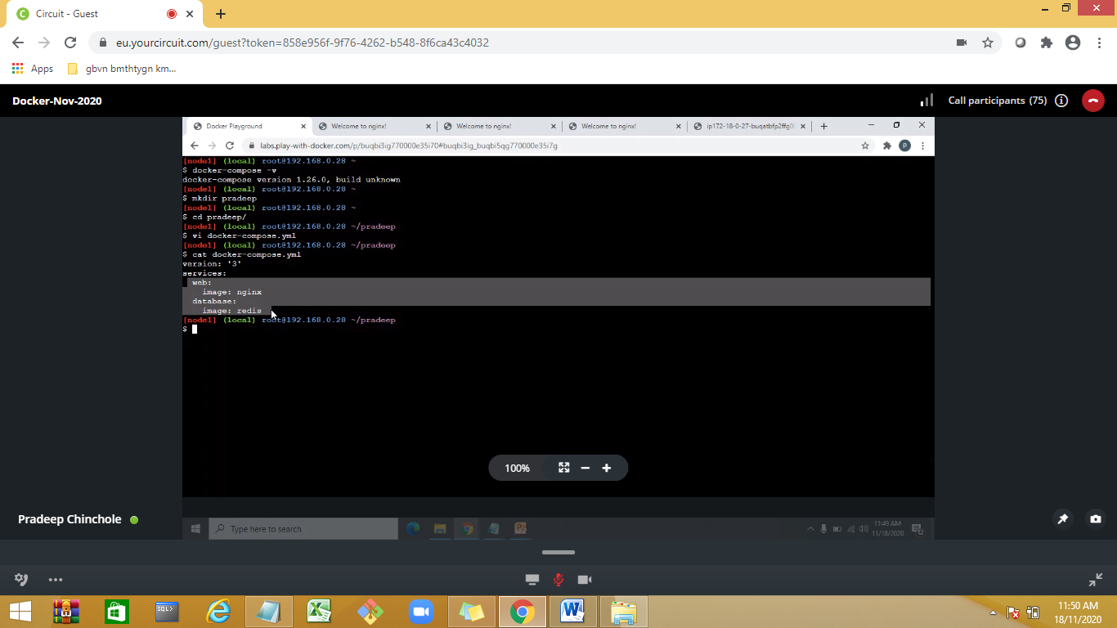

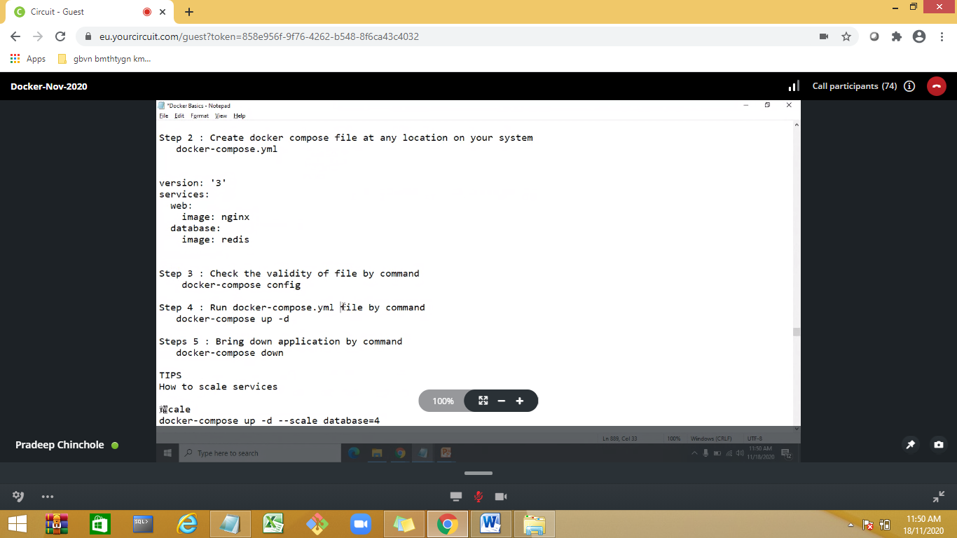

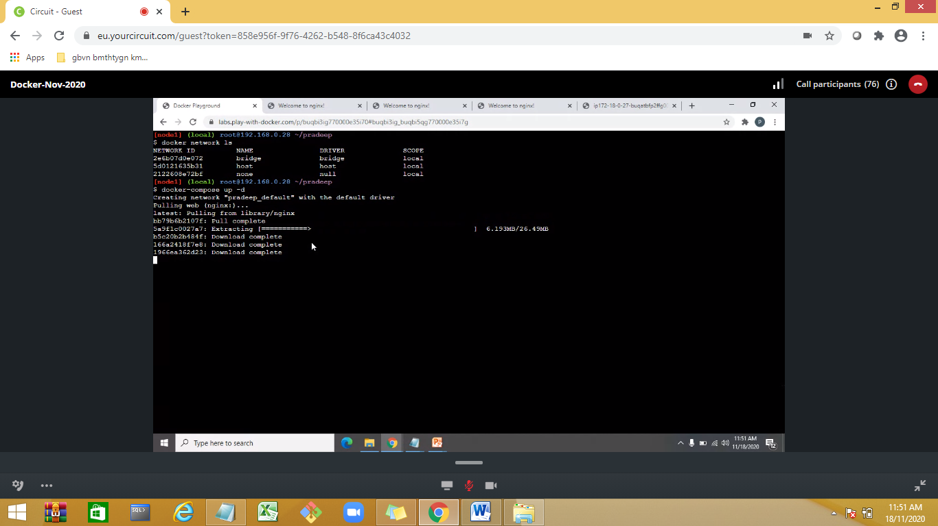

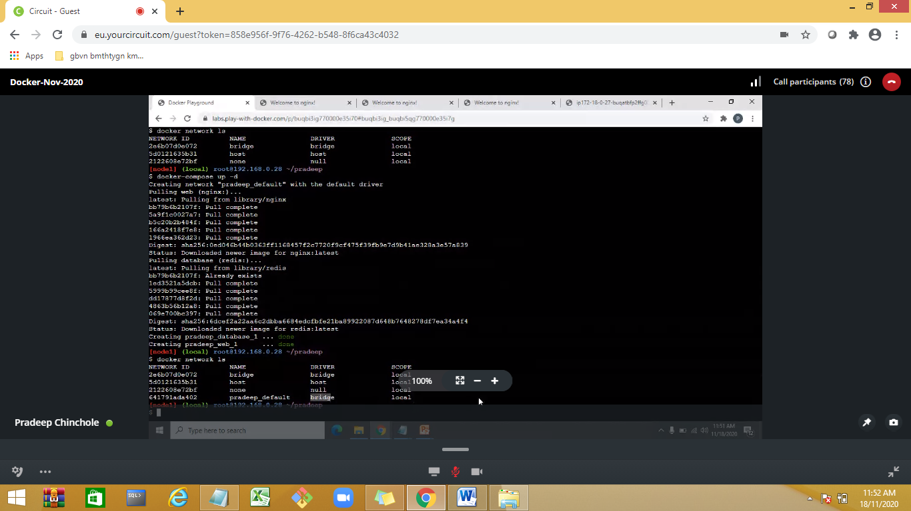

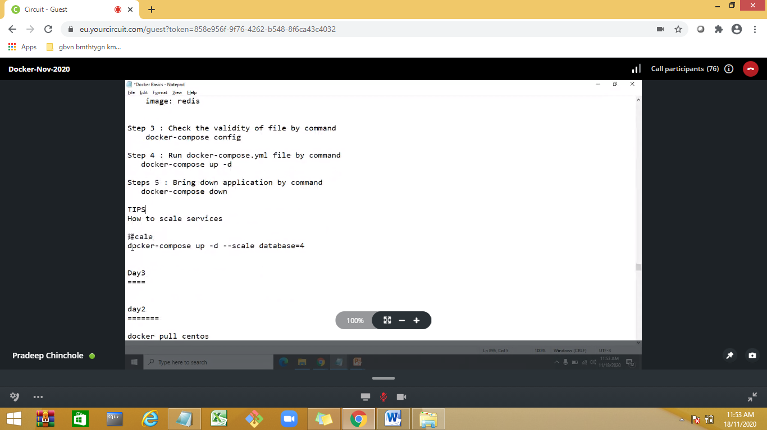

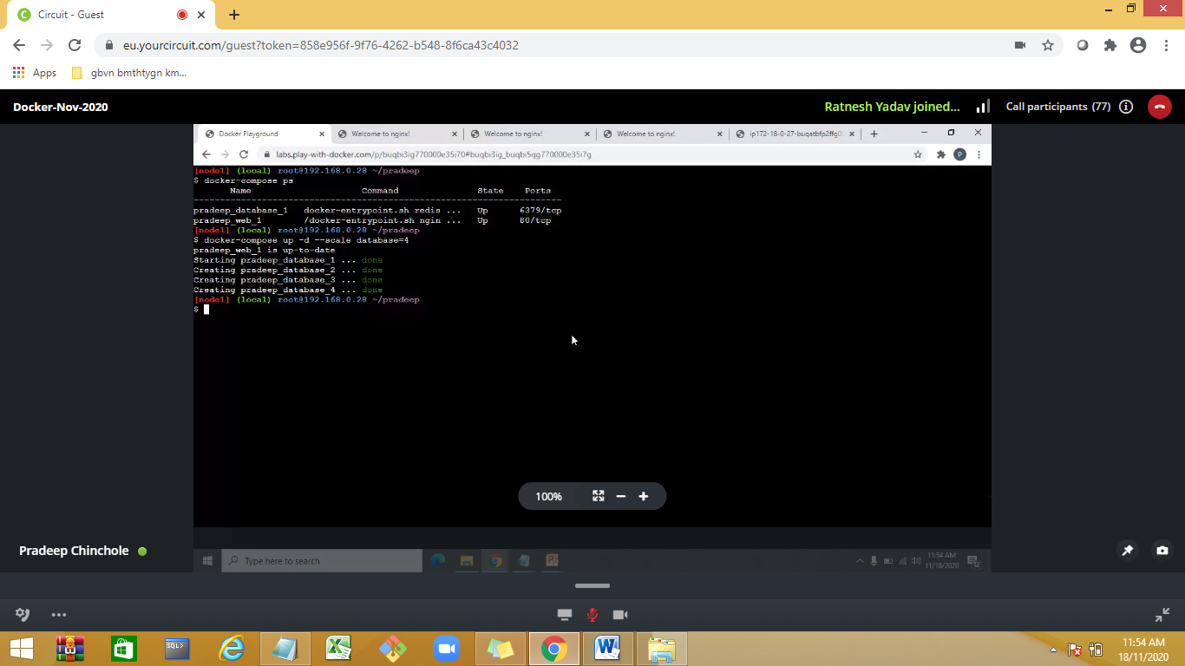

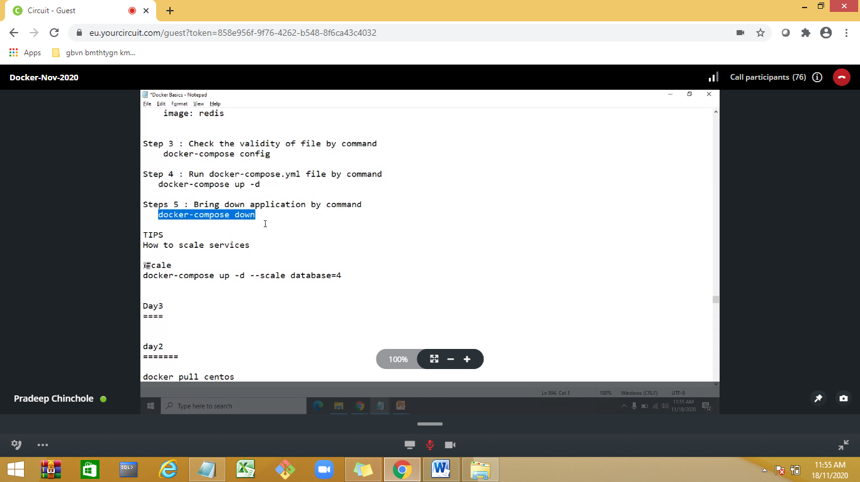

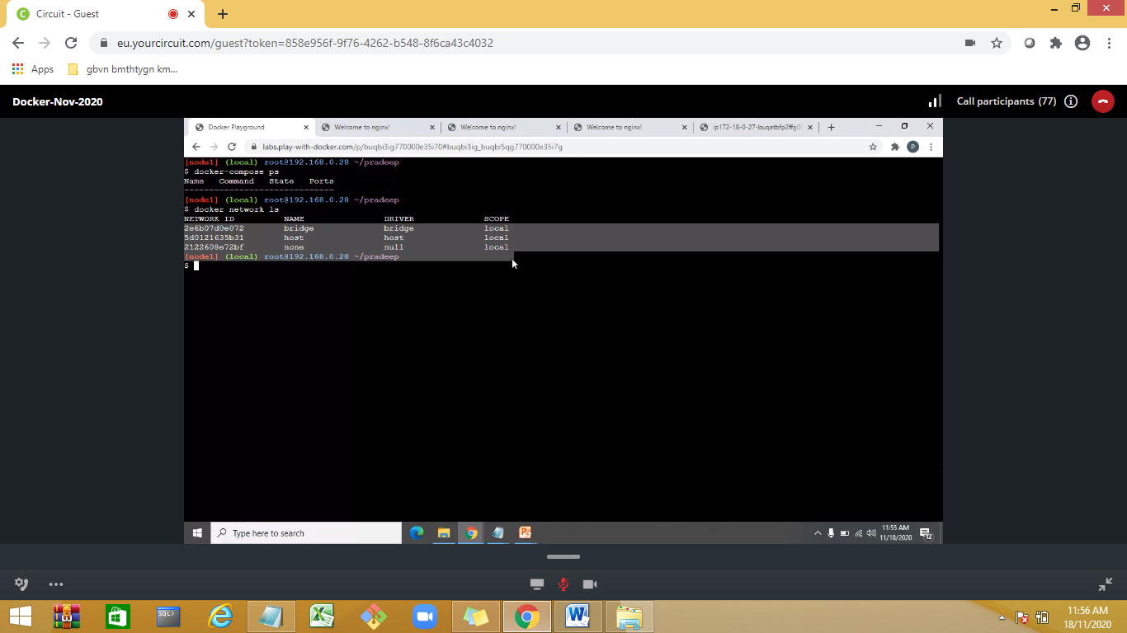

Docker compose helps in scaling up and down

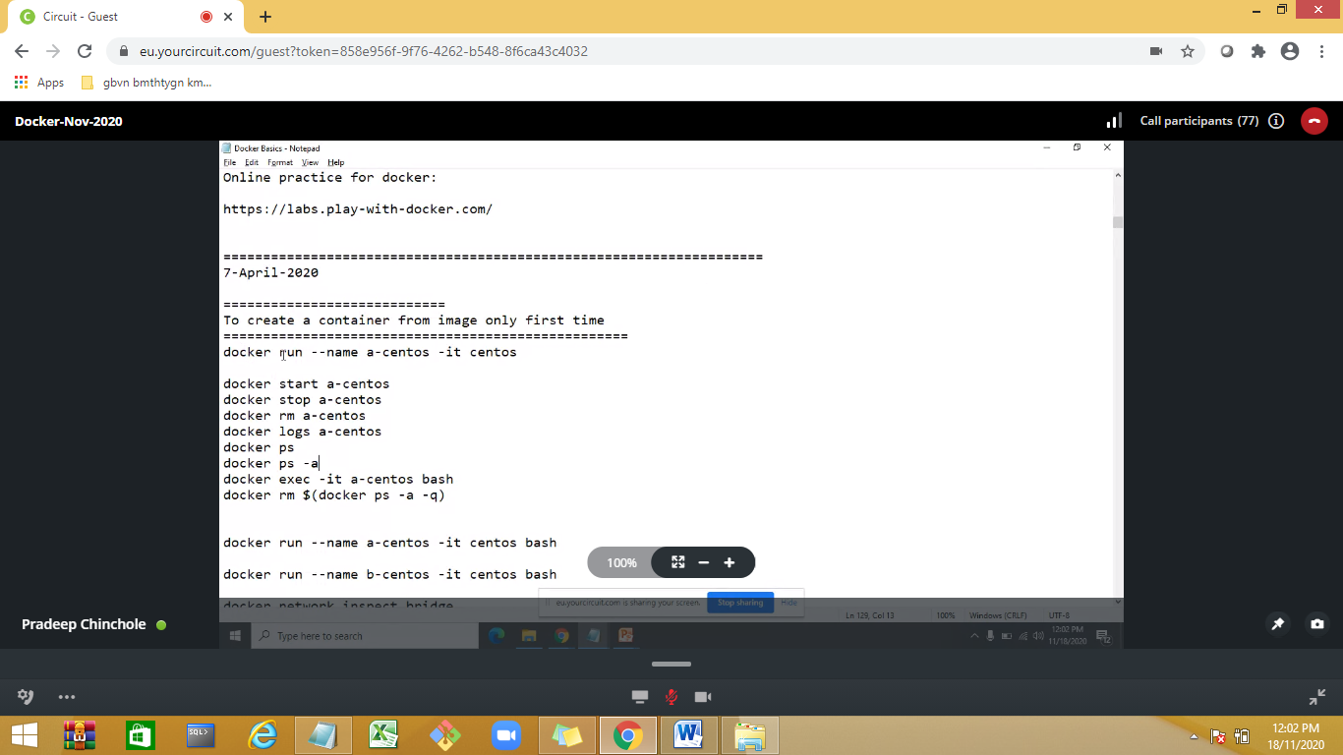

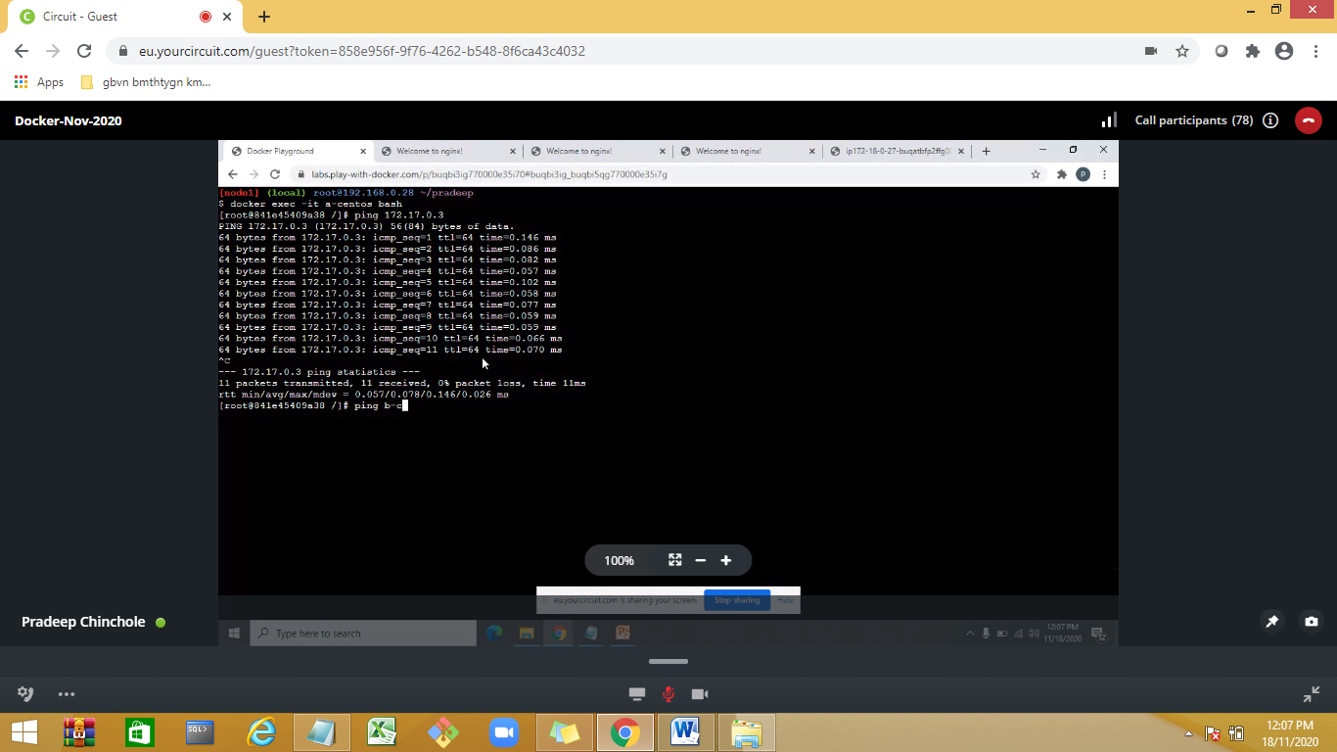

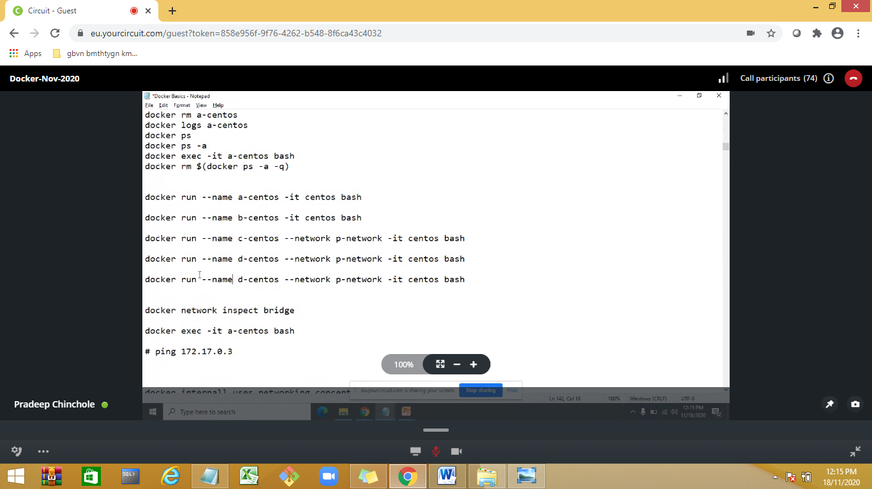

Day 2:

Virtuali—hardware level

<https://eu.yourcircuit.com/guest?token=858e956f-9f76-4262-b548-8f6ca43c4032>

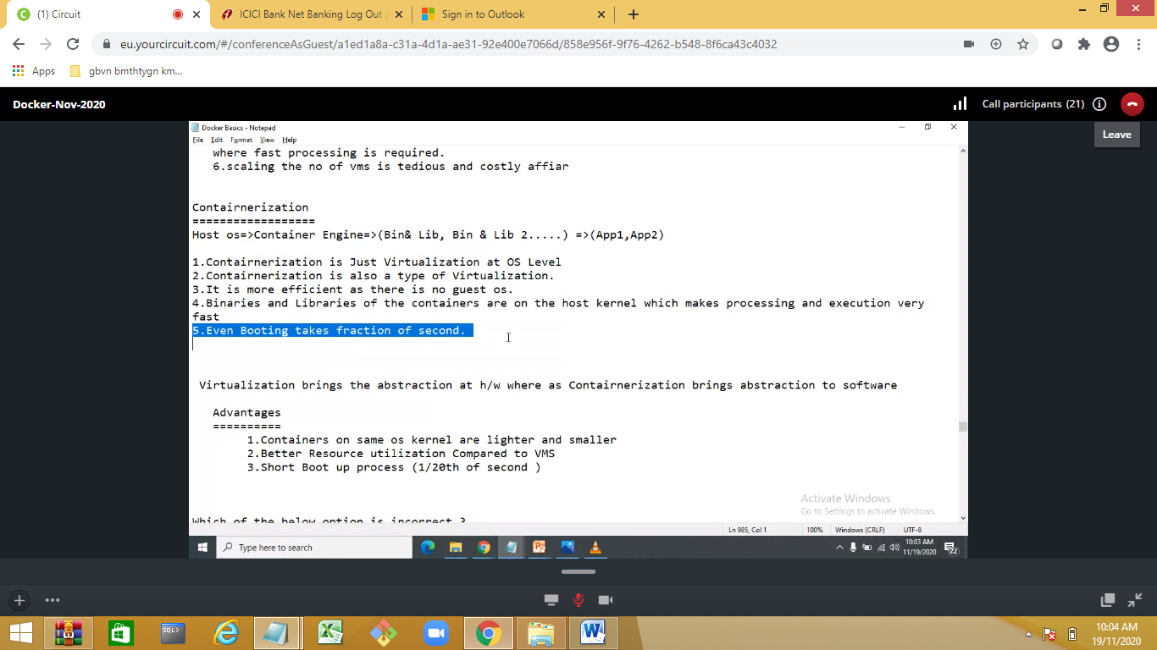

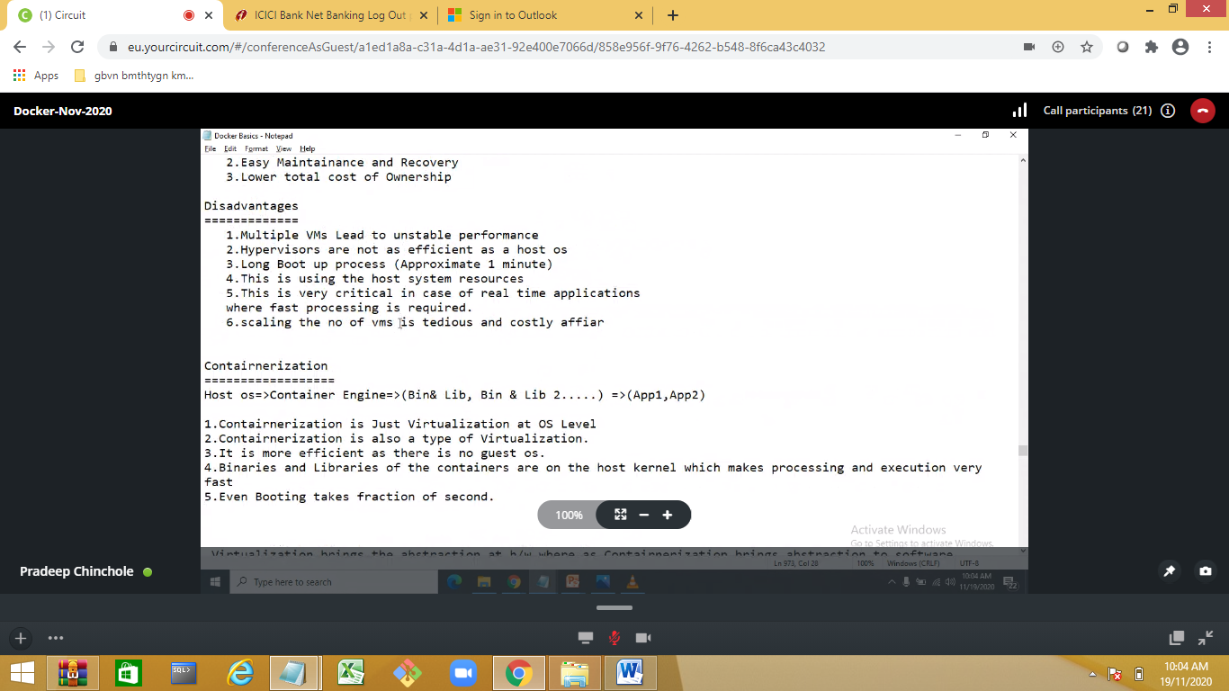

Custom Images

Building image:

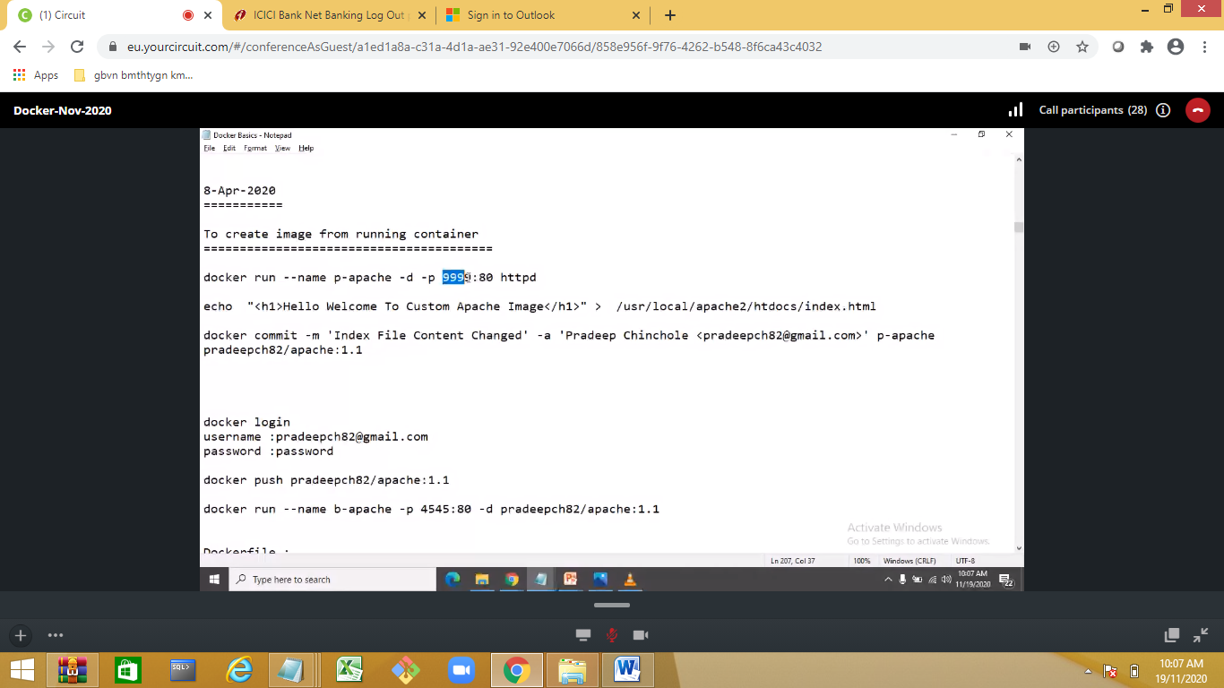

Httpd=--apache server

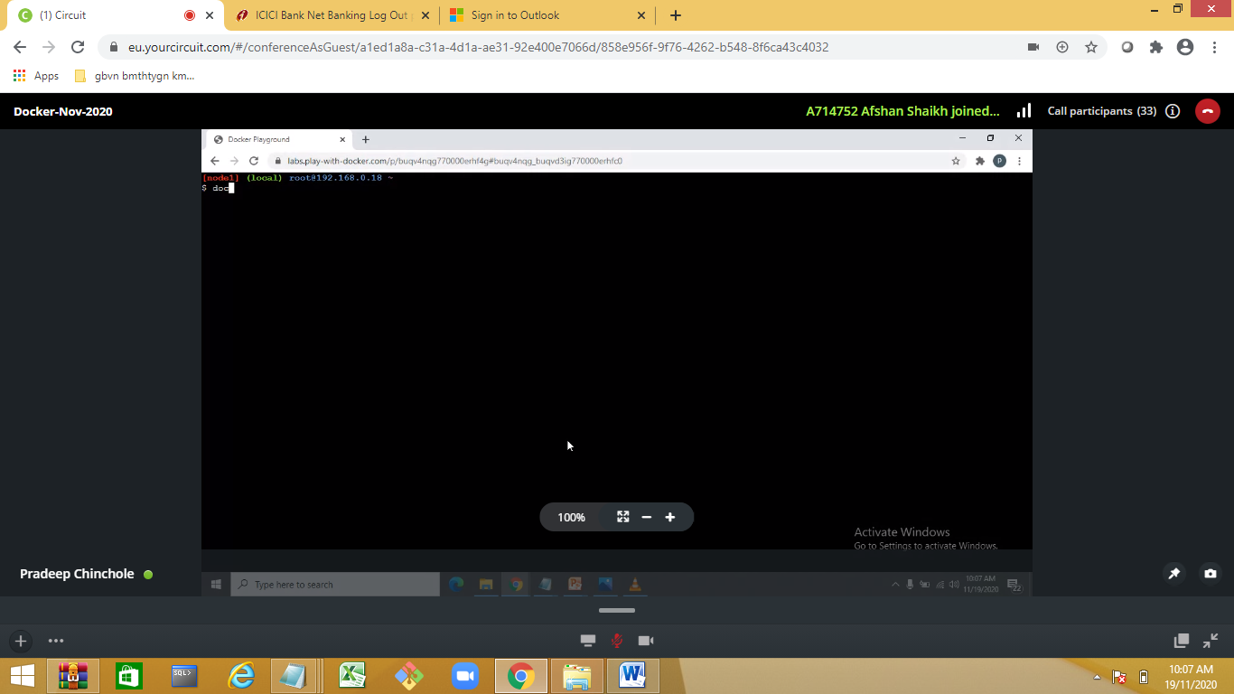

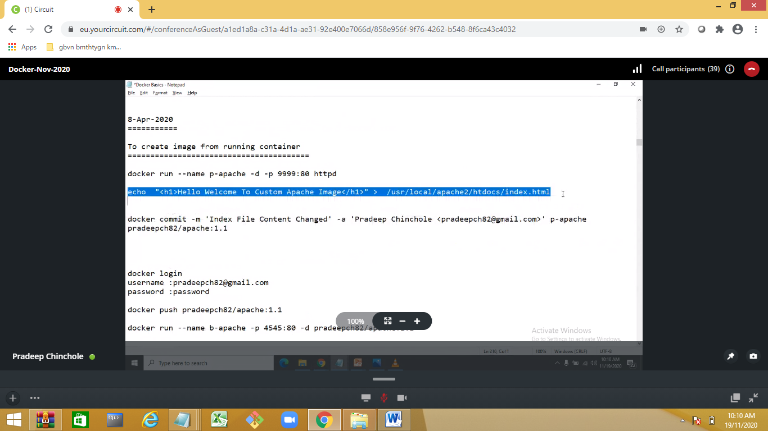

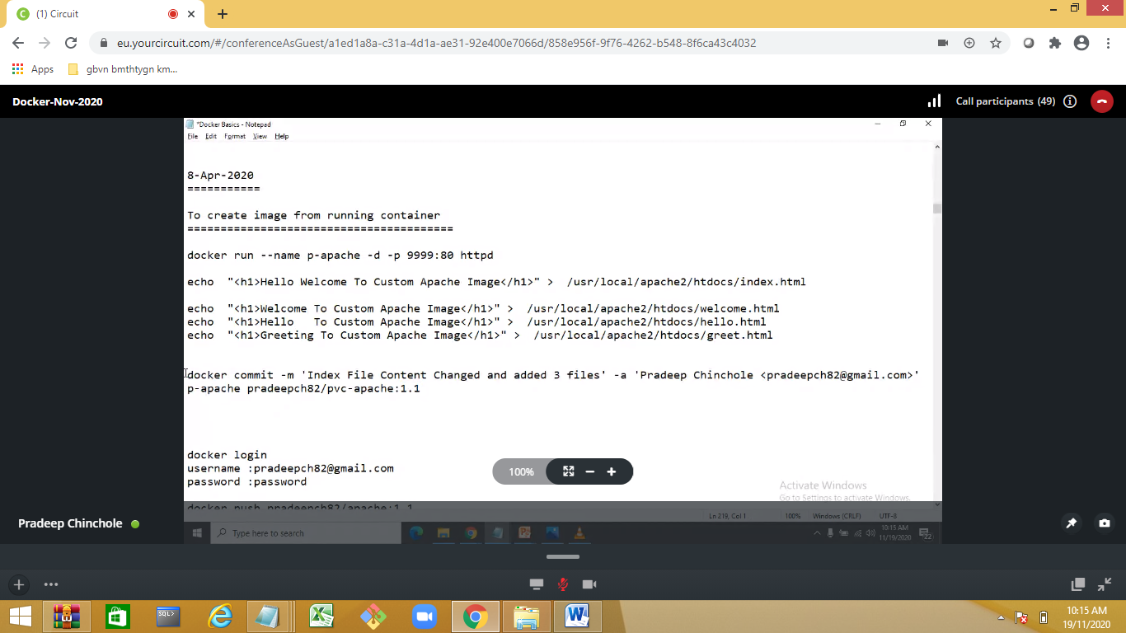

Localimage to docker hub

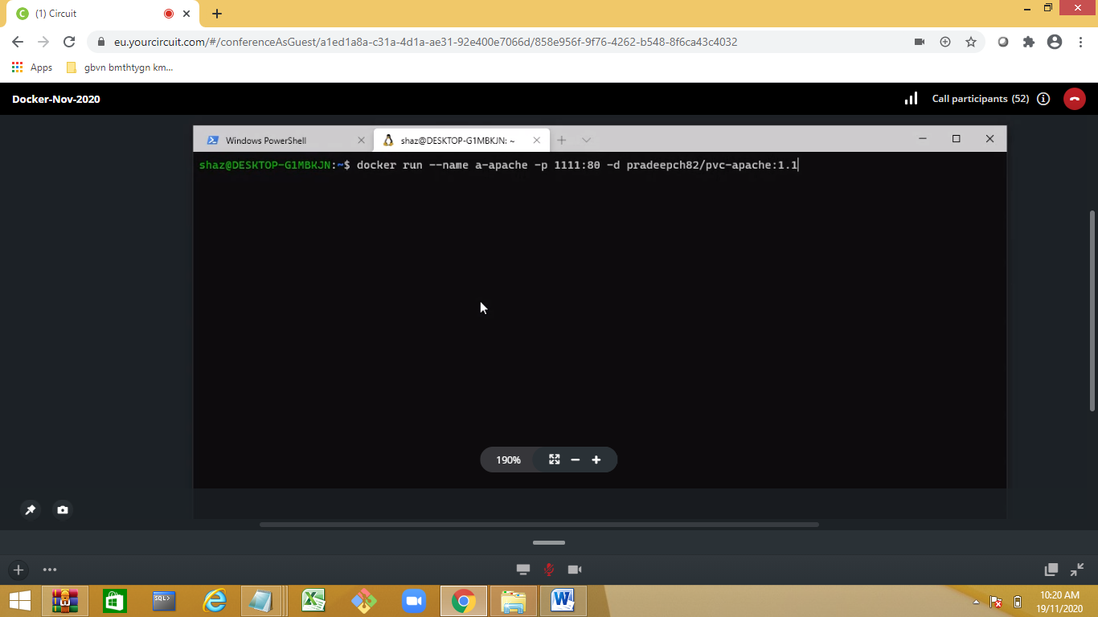

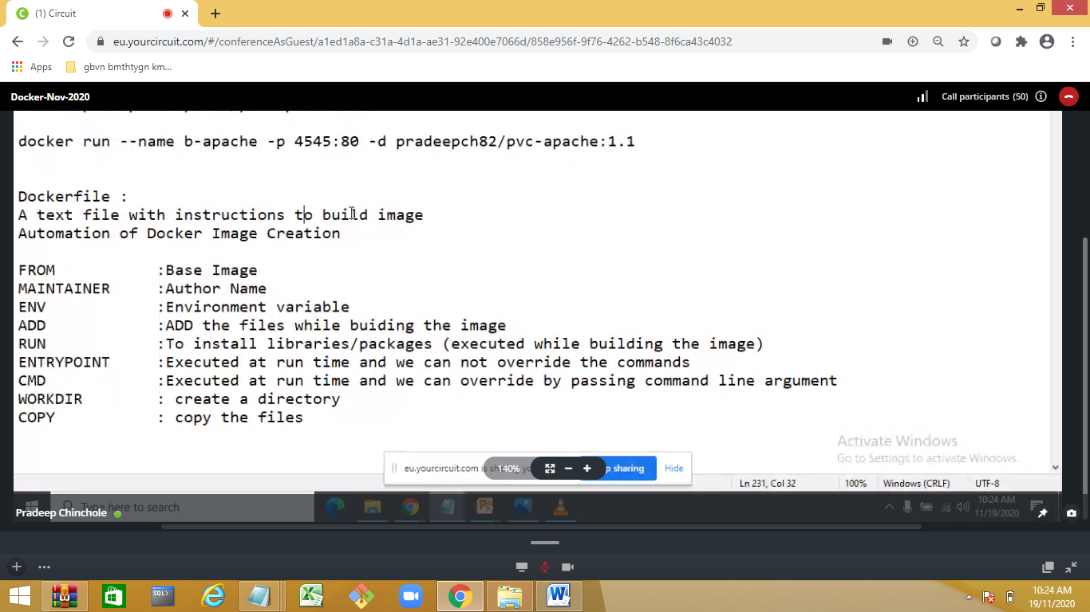

Explain the docker file

CMD –shd use only once

https://labs.play-with-docker.com/

JDK IMAGE

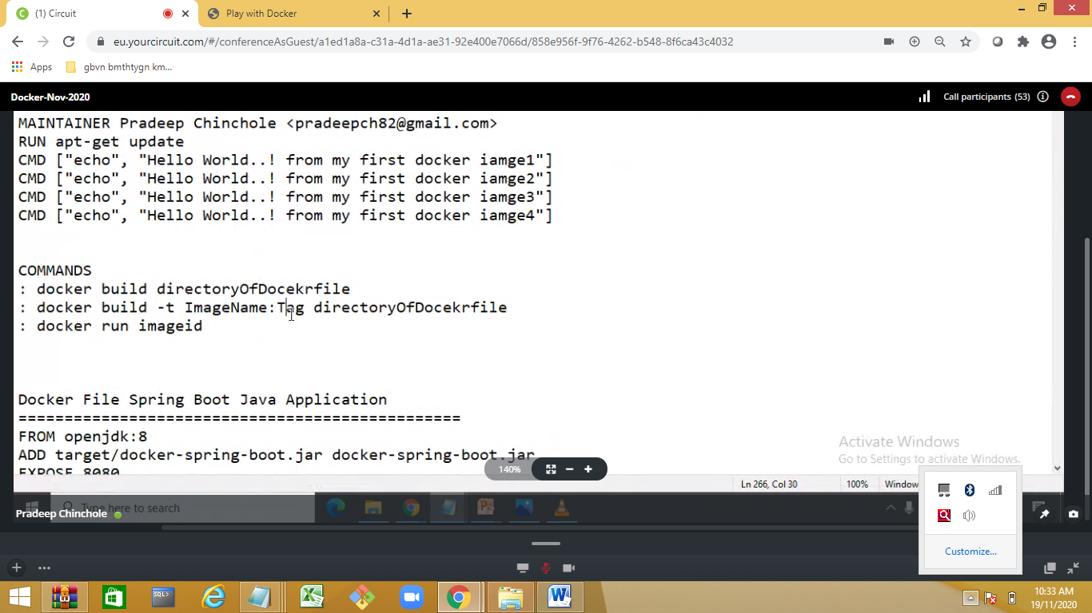

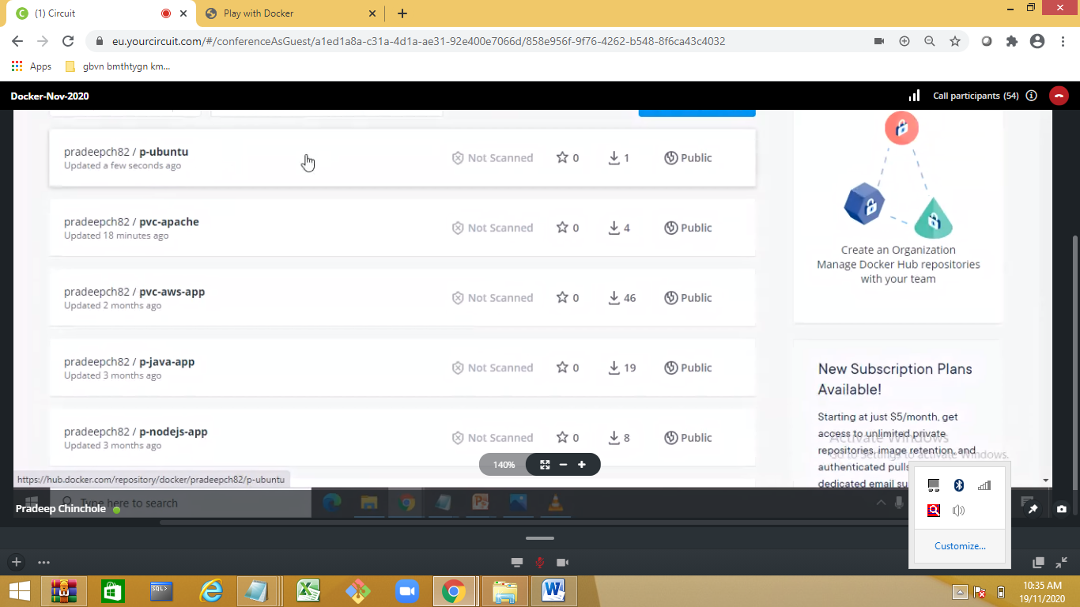

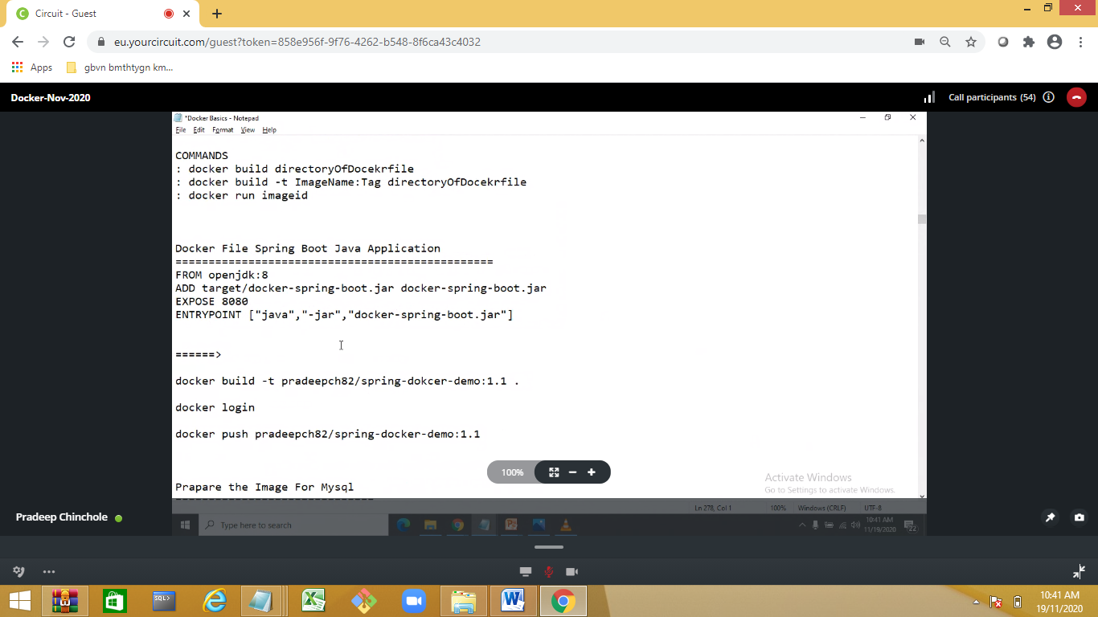

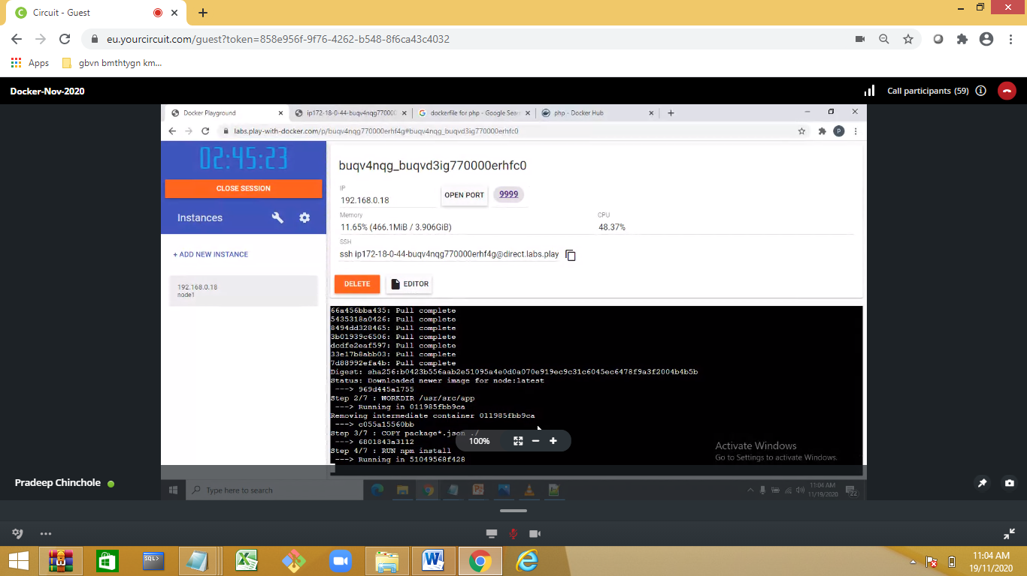

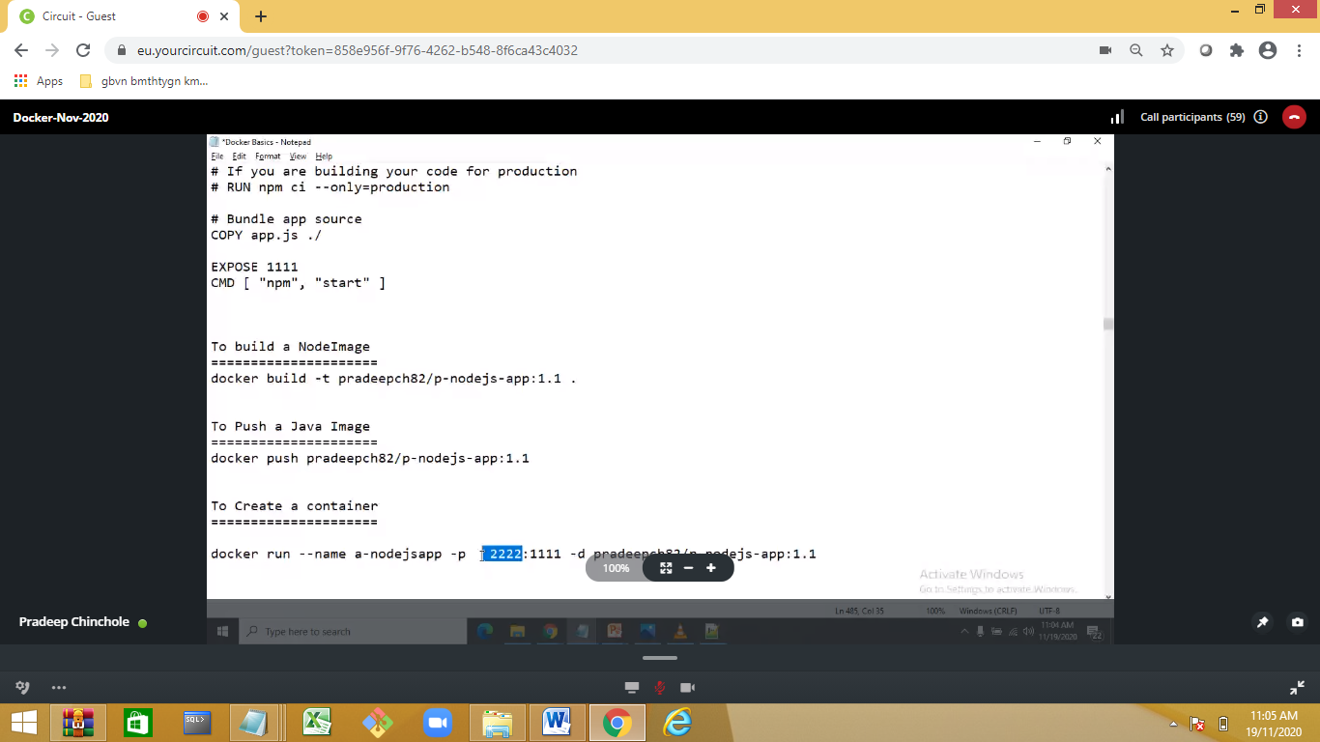

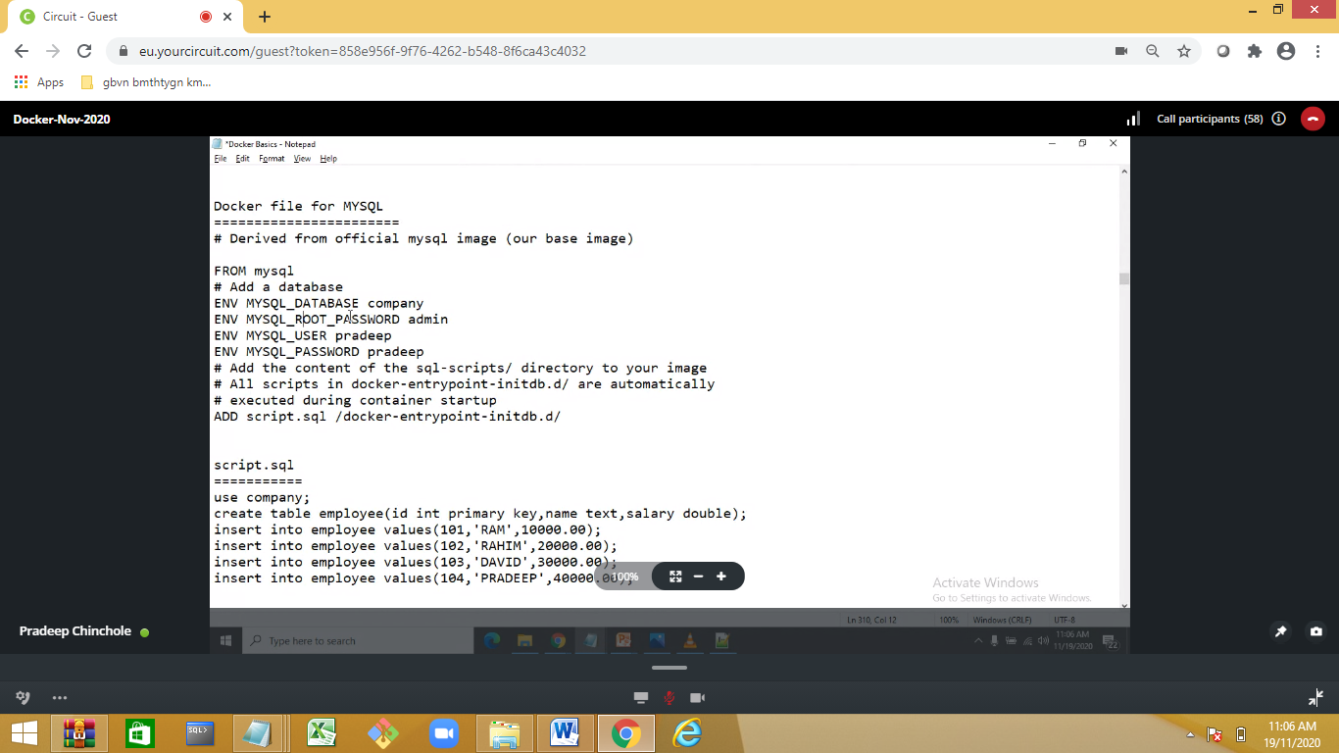

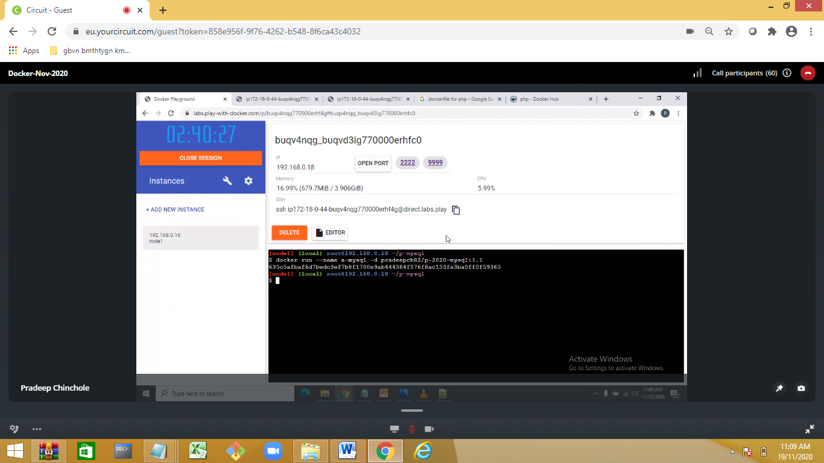

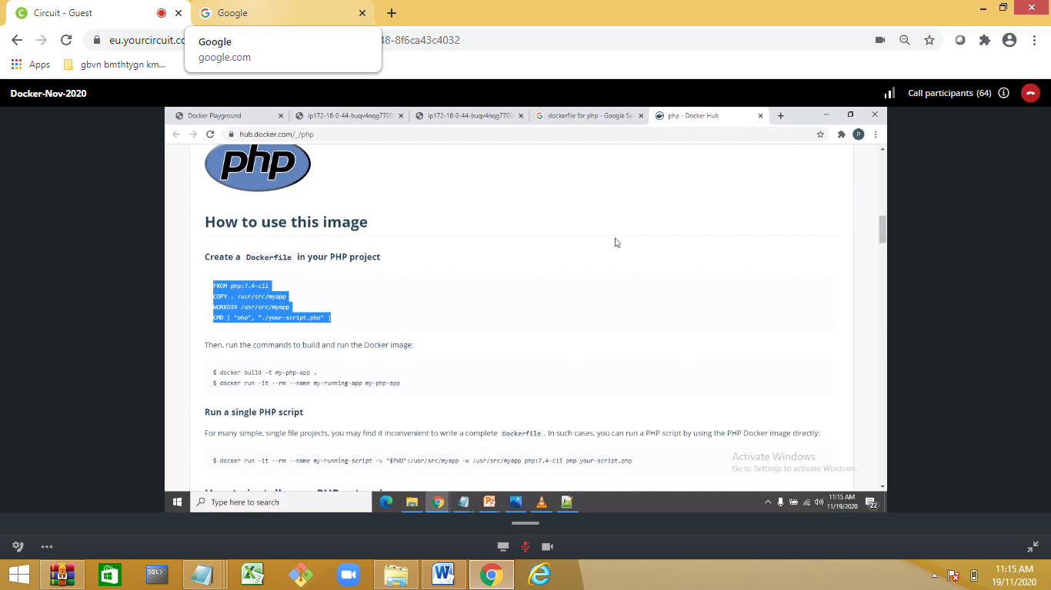

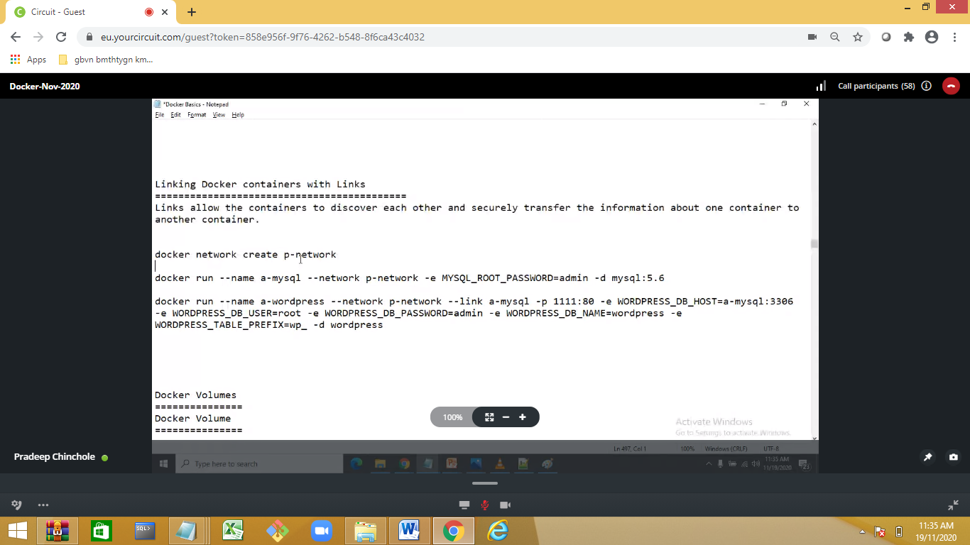

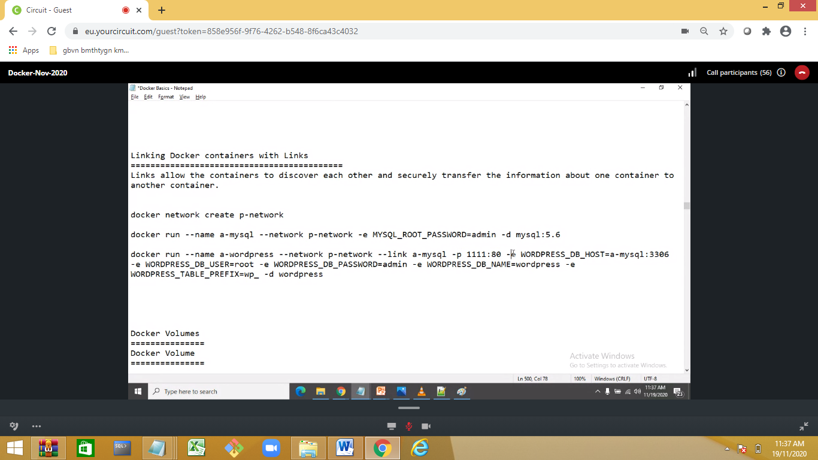

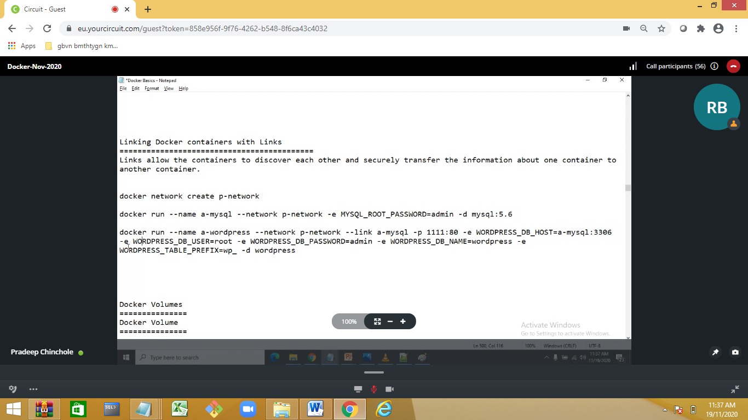

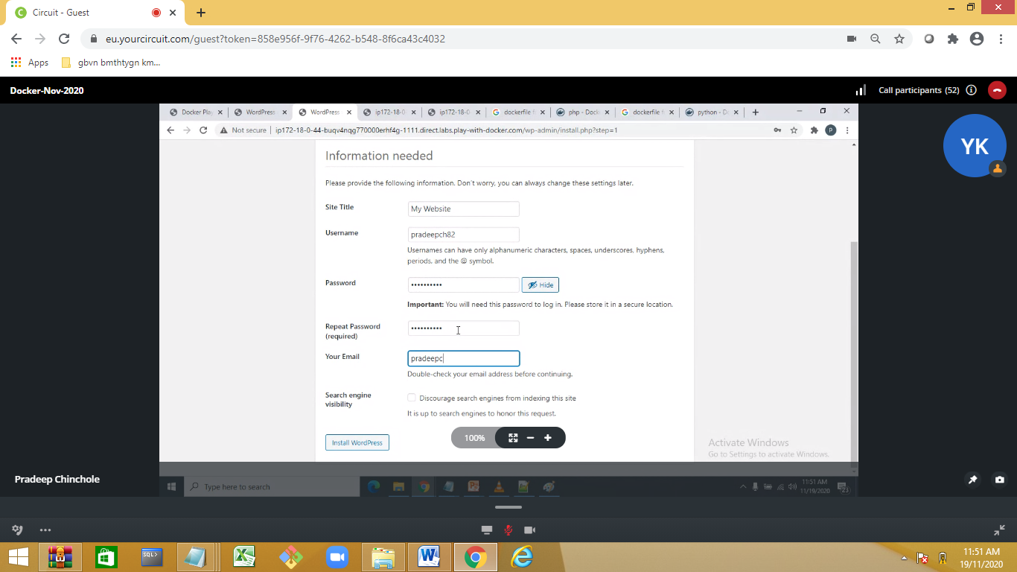

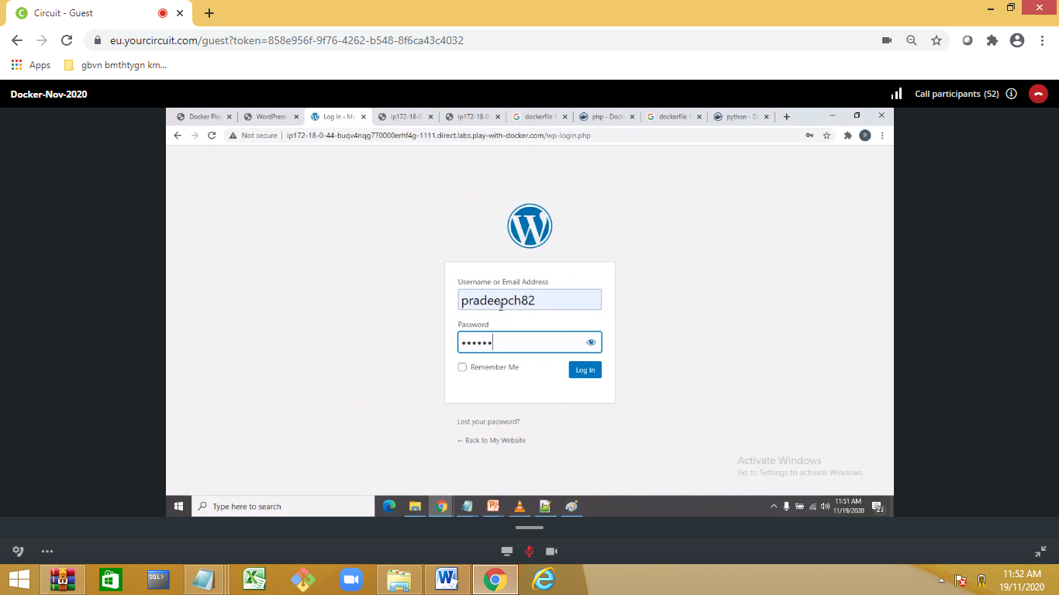

Day 3:

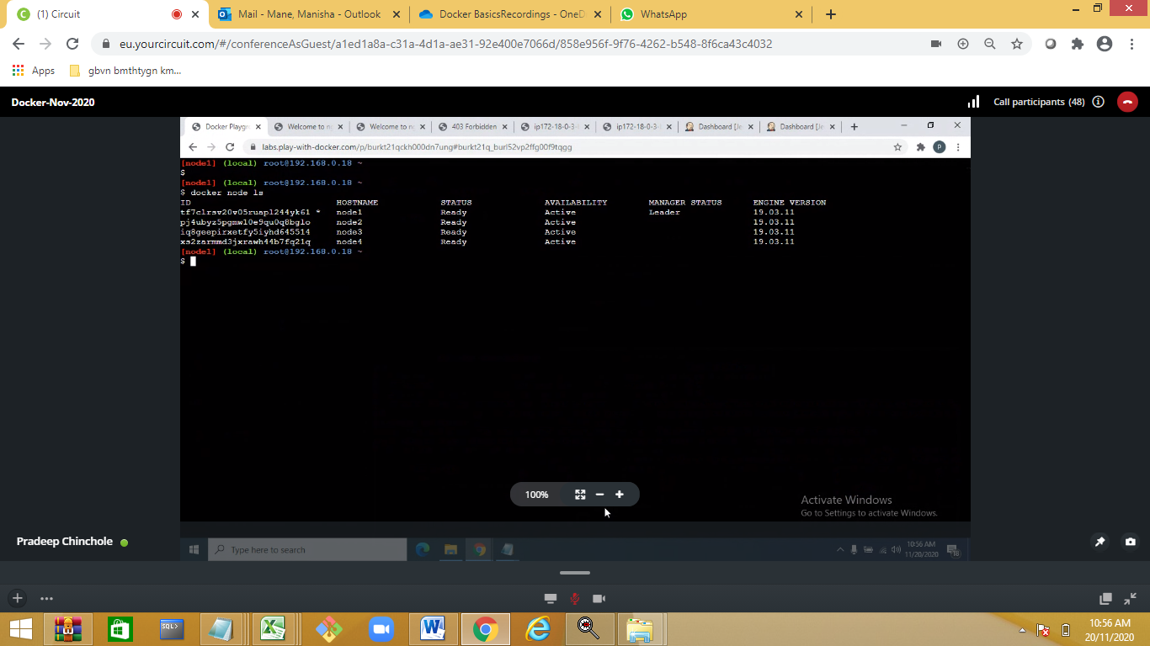

Creating node

